|  |
| --- |
| Close-up image showing the leaf-sides of two oversized books side-by-side on a bookshelf, with additional books in soft focus background |
| Selenium Webdriver with Java  Beginners Guide |
| |  |  |  | | --- | --- | --- | | Sanjana Koirala | 2/16/24 | Automation with Selenium | |

# **Table of Contents**

**What will I learn?** v

**Technology Used** vi

**What you need to Know?** vii

**1** **Introduction** 1

**2** **Environment preparation** 2

2.1 Installation 2

2.1.1 Java Installation 2

2.1.2 Maven Installation 3

2.1.3 Eclipse Installation 4

2.2 Create a New Maven Project 5

2.2.1 Maven Standard directory layout 7

2.3 Configure Maven Project 8

2.3.1 Apache Maven: 9

2.3.2 Maven Surfire Plugim 10

2.3.3 TestNG dependency 11

2.3.4 Selenium dependency 12

2.3.5 Save and Update project 13

**3** **Creating first basic test** 14

3.1 Creating a test class 14

3.2 Building a test method 15

3.3 Running tests with TestNG 17

3.3.1 Running tests in cmd 17

3.3.2 Running tests in eclipse 19

3.4 Identifying page elements and locators 21

3.4.1 Elements 21

3.4.2 Locators 21

3.4.3 Creating locators with Ranorex Selocity extension 21

3.4.4 Creating locators manually 23

3.5 Introduction to WebElement 24

3.6 WebDriver commands in Selenium 25

3.7 Implementing Verification and Assertions in Selenium 26

**4** **Creating and Running Test Suites** 28

4.1 TestNG Eclipse Plugin for Selenium 28

4.2 Negative testing 30

4.3 Building TestNG Test Suite 33

4.4 Running TestNG Test Suite 35

**5** **Benefits of TestNG Framework** 36

5.1 Parameters from TestNG documentation 36

5.1.1 Priority parameter 36

5.1.2 Enabled parameter 37

5.2 Organizing Tests with TestNG Groups 38

5.3 Include or exclude specific test methods. 40

5.4 Parameters from test suite. 42

5.5 Combining Login Tests in Selenium. 45

5.6 Using TestNG Before and After Annotations. 47

5.6.1 @BeforeMethod implementation with setup method 47

5.6.2 Issue with BeforeMethod: 48

5.6.3 @AfterMethod implementation with teardown method: 48

5.7 Cross Browser Testing with Selenium and TestNG. 49

**6** **Debugging common test failures** 51

6.1 Debugging Techniques for Selenium WebDriver Tests 51

6.1.1 Step Into: 55

6.1.2 Step Over: 55

6.1.3 Step Return: 55

6.1.4 Resume: 55

6.2 Exception Handing in Selenium WebDriver 56

6.3 Dealing with NoSuchElementException in Selenium 58

6.3.1 Handling NoSuchElementException in Selenium with thread.sleep: 59

6.4 Understanding WebDriver Waits in Selenium 60

6.5 Implementing Implicit Wait in Selenium Tests 61

6.6 Implementing Explicit Wait in Selenium Tests 62

6.7 Handling ElementNotInteractableException in Selenium 63

6.8 Solving InvalidElementStateException in Selenium 65

6.9 Fixing StateElementReferenceException in Selenium 67

6.10 Overcoming TimeoutException in Selenium Tests 68

**7** **Introduction to Advanced Selenium WebDriver with Java and TestNG** 70

# **What will I learn?**

* Where to start in test automation?
* Prepare environment.
* Create first automated test.
* Page elements locator
* Run test in few ways.
* Benefits of TestNG framework
* Most common test exceptions

# **Technology Used**

* Java: Programming language
* Maven: Project Management
* TestNG: Testing framework
* Eclipse IDE

# **What you need to Know?**

* **Software Testing experience:**

Prior testing experience is required, should know how to create tests manually and execute them accordingly.

* **Basic or no Java programming language**

# **Introduction**

**Selenium WebDriver:**

* Browser automation framework, commonly used for writing end-to-end tests of web applications.
* It is basically a library for browser automation.
* Supports almost any programming language.
* No built-in framework to run tests that’s why we need to use other frameworks like Junit, TestNG to run tests depending on the language we use to write code.
* We must manage browser versions.

**Selenium WebDriver 4(W3C standardized)**

**Maven:** Build management tool used for java projects for better structure and easy dependency management.

**IDE (Integrated development environment):** Software application that provides comprehensive facilities to programmers for software development. In simple words, it helps you write code.

# **Environment preparation**

## Installation

### Java Installation

1. Verify java installation:

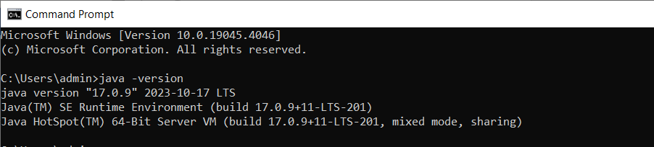

1. Download and Install Java Development Kit (JDK) if not verified:

* Go to oracle website:

[Java Downloads | Oracle](https://www.oracle.com/java/technologies/downloads/#java21)

* Choose the LTS java version:

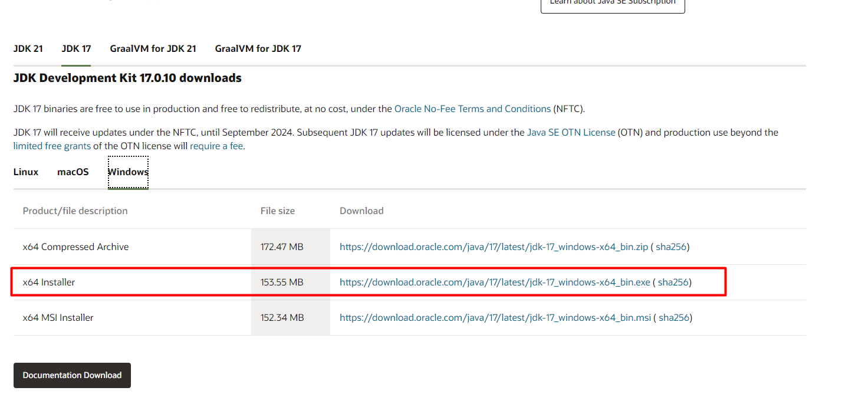

**Guide to download and install Java JDK in windows(64-bit):**

[How to Download & Install Java JDK 8 in Windows 10 (64-bit) (guru99.com)](https://www.guru99.com/install-java.html)

**Guide to set environment variables in windows:**

[How to set JAVA_HOME on Windows 10? - Mkyong.com](https://mkyong.com/java/how-to-set-java_home-on-windows-10/)

### Maven Installation

1. Verify Maven installation:

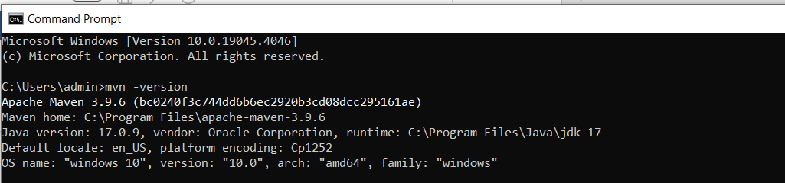

1. Download and Install Maven if not verified:

* Go to apache maven download page:

[Maven – Download Apache Maven](https://maven.apache.org/download.cgi)

* Download the zip file:

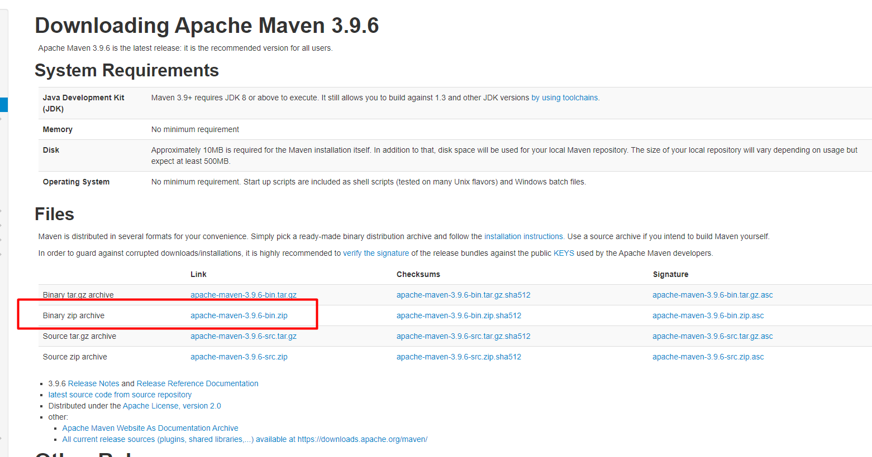

### Eclipse Installation

1. Go to eclipse official page:

[Eclipse Downloads | The Eclipse Foundation](https://www.eclipse.org/downloads/)

1. Download eclipse:

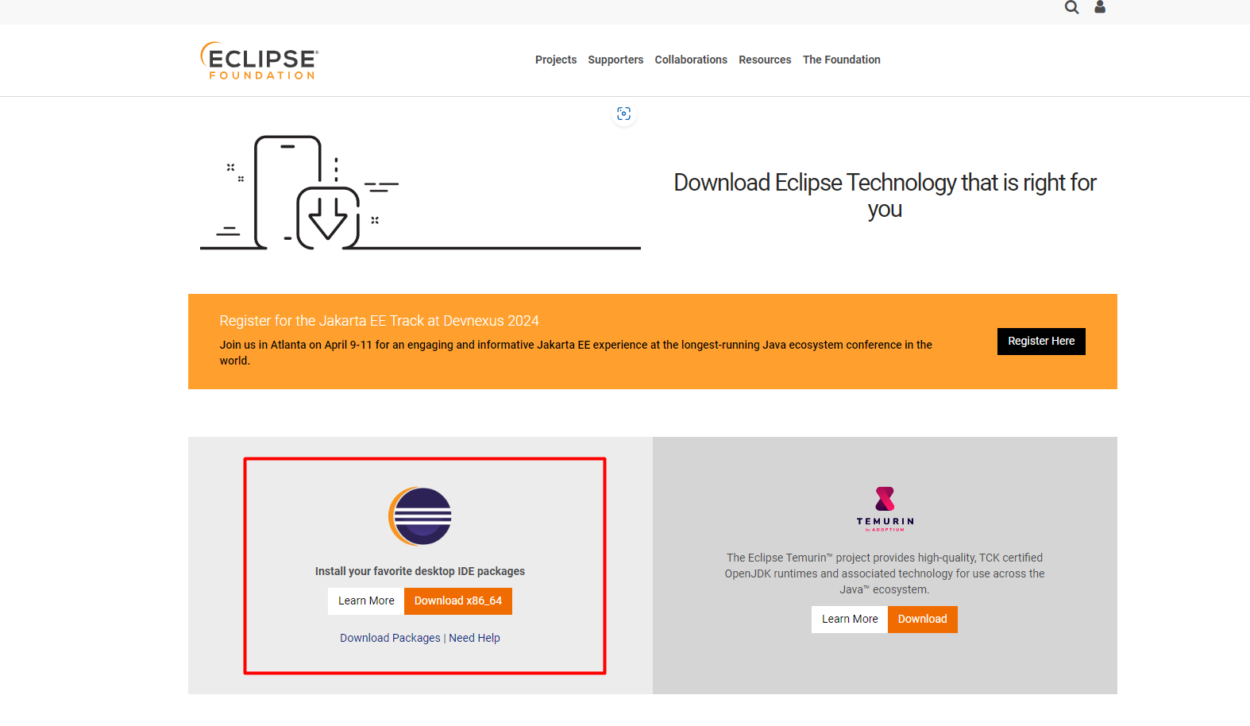

## Create a New Maven Project

**Steps:**

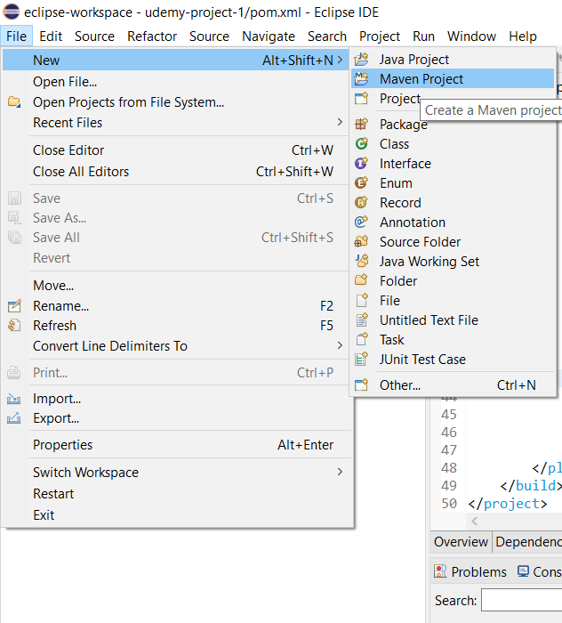

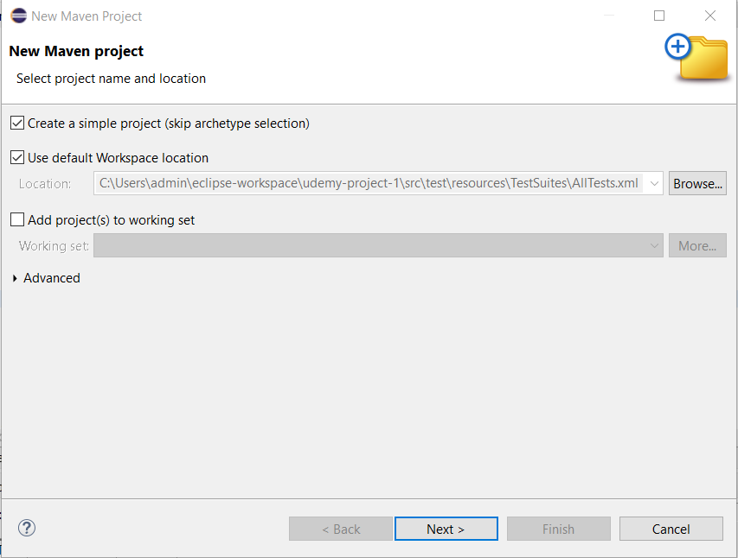

(Dummy test site: [The Internet (the-internet.herokuapp.com)](https://the-internet.herokuapp.com/))

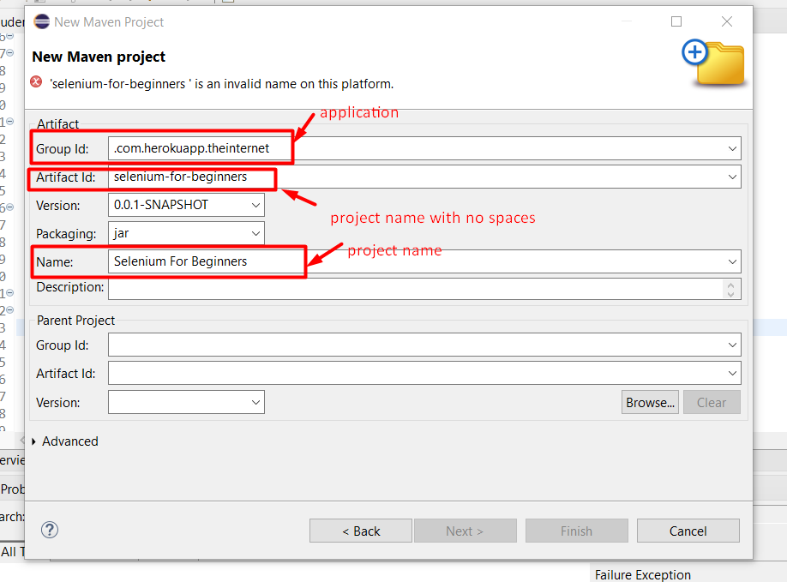

### Maven Standard directory layout

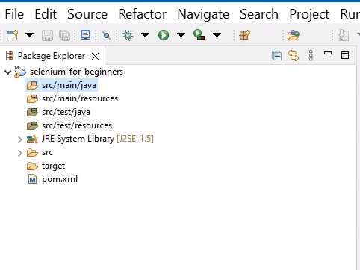

* **src/main/java:** keep source files.
* **src/main/resources:** resources needed in project, e.g. browser drivers.
* **src/test/java:** test files.
* **src/test/resources:** test resources such as suite files or data providers.

## Configure Maven Project

* Open pom.xml file
* Add Apache Maven compiler plugin and Maven Surfire plugin
* Add testNG dependency.
* Add selenium dependency.
* Save and update project.

***Note:***

* *Pom.xml file is the core of the project’s configuration in Maven. It is a single configuration file that contains most of the information required to build a project in just the way you want.*
* *Maven Surefire plugin is used to run tests and generate reports in java applications*

### Apache Maven:

Link: [Apache Maven Compiler Plugin – Introduction](https://maven.apache.org/plugins/maven-compiler-plugin/index.html)

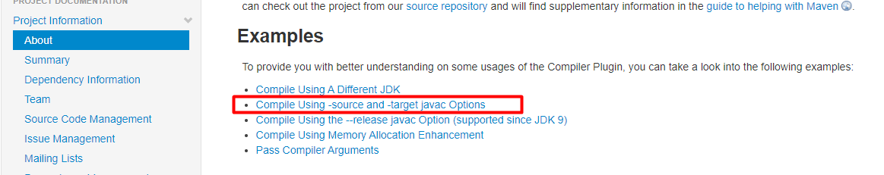

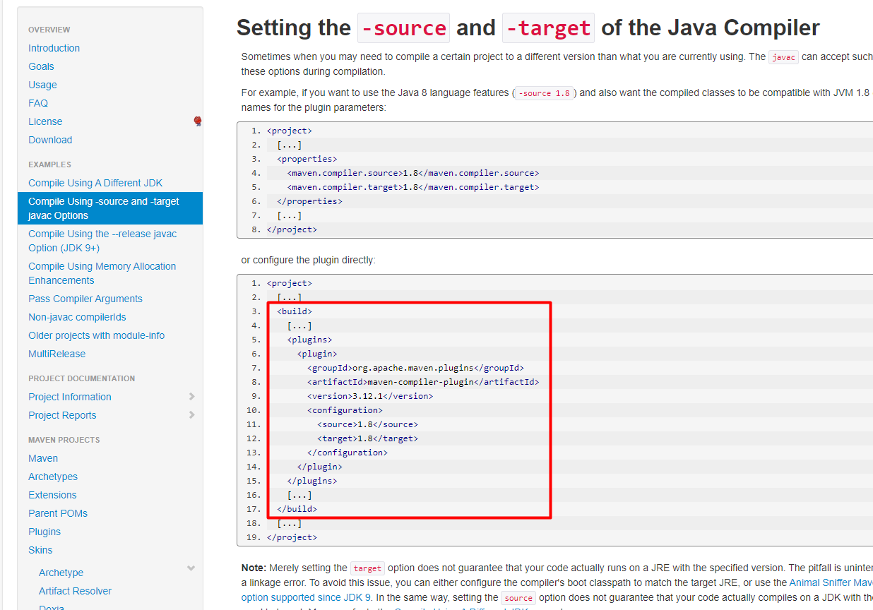

In pom.xml:

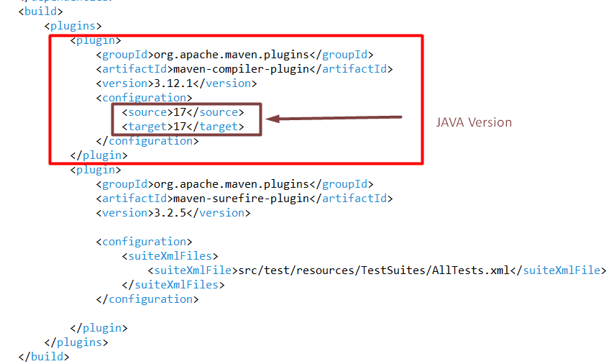

### Maven Surfire Plugim

Link: [Maven Surefire Plugin – Introduction (apache.org)](https://maven.apache.org/surefire/maven-surefire-plugin/)

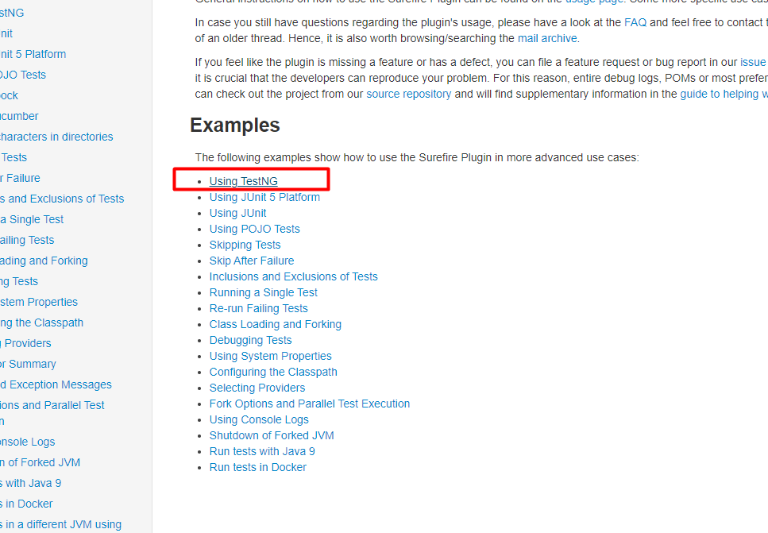

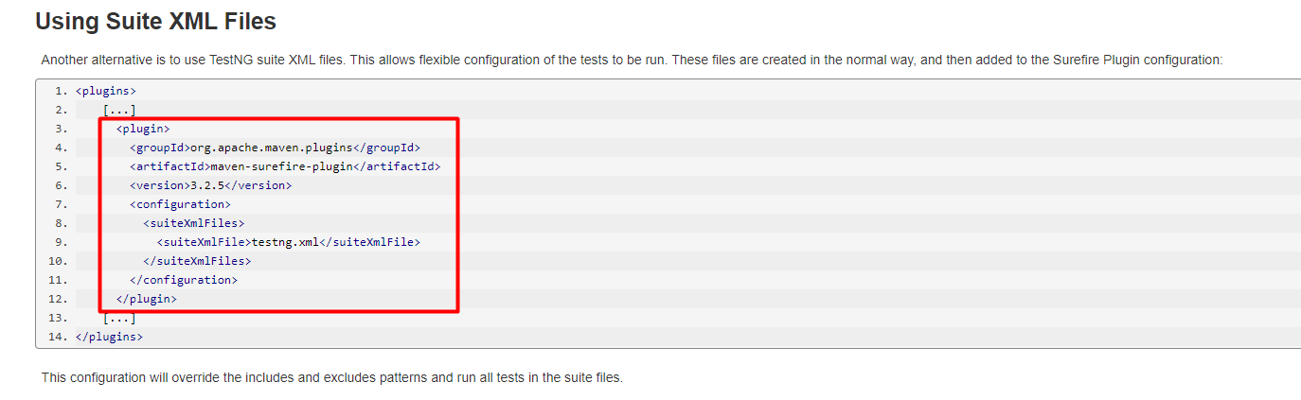

In pom.xml:

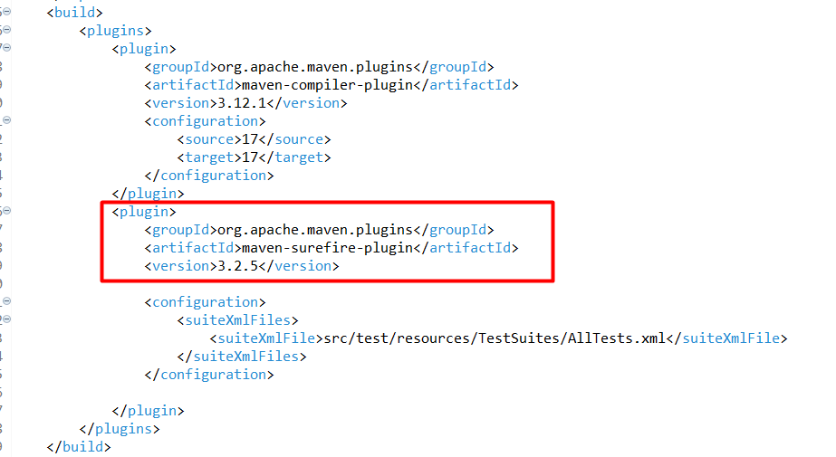

### TestNG dependency

Link: [Maven Repository: org.testng » testng (mvnrepository.com)](https://mvnrepository.com/artifact/org.testng/testng)

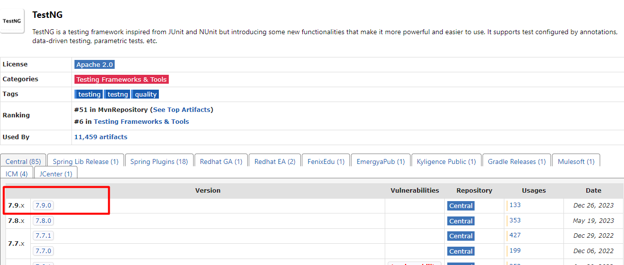

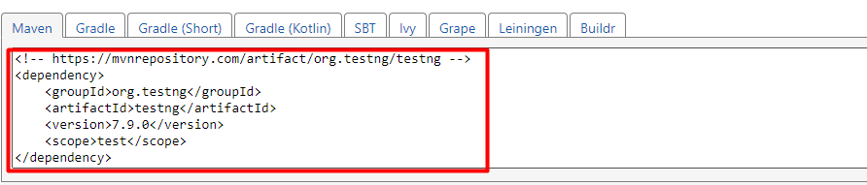

In pom.xml:

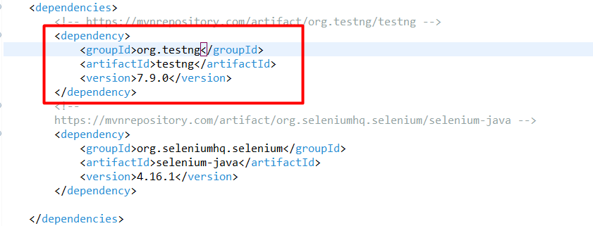

### Selenium dependency

Link: [Maven Repository: org.seleniumhq.selenium » selenium-java (mvnrepository.com)](https://mvnrepository.com/artifact/org.seleniumhq.selenium/selenium-java)

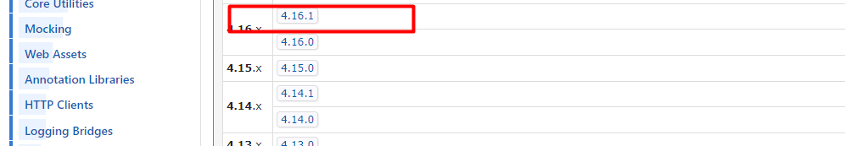

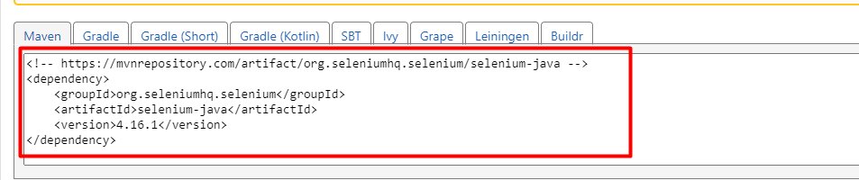

In pom.xml:

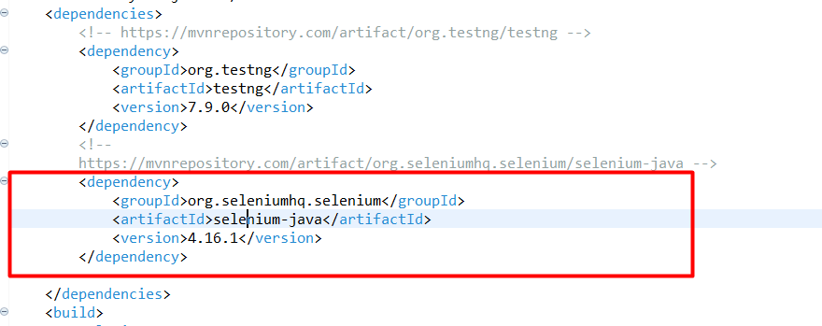

### Save and Update project

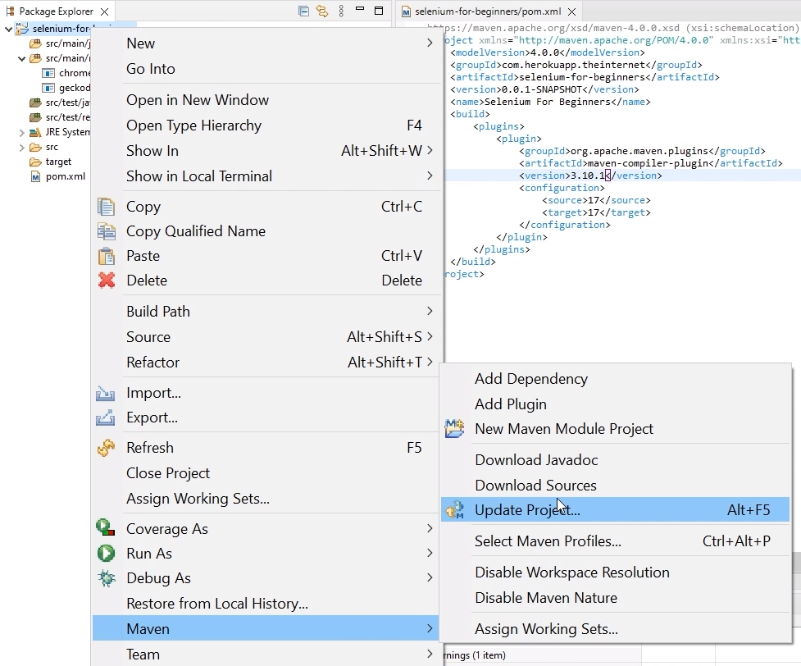

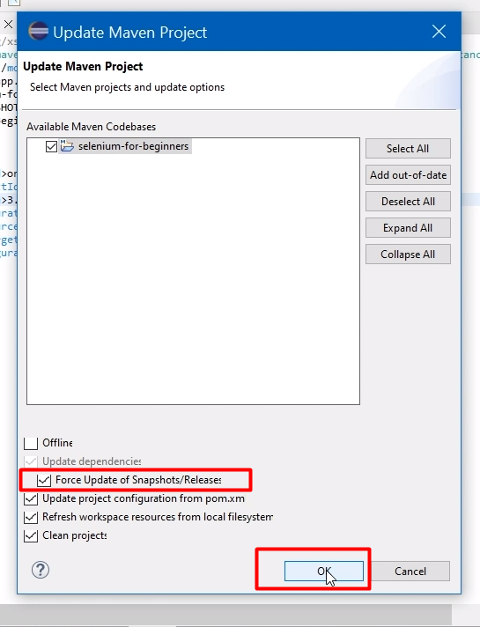

# **Creating first basic test**

## Creating a test class

* Create a package:

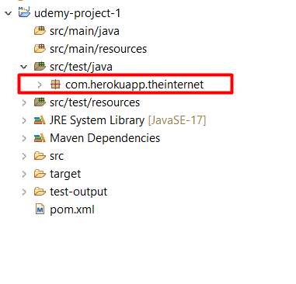

* Create a java class:

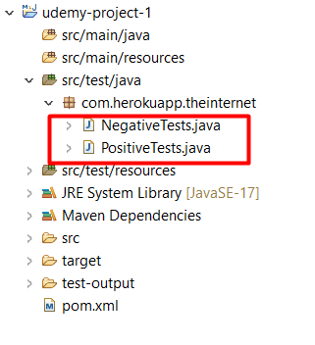

## Building a test method

* Create a method and write test steps:

(Login test url: [The Internet (the-internet.herokuapp.com)](https://the-internet.herokuapp.com/login))

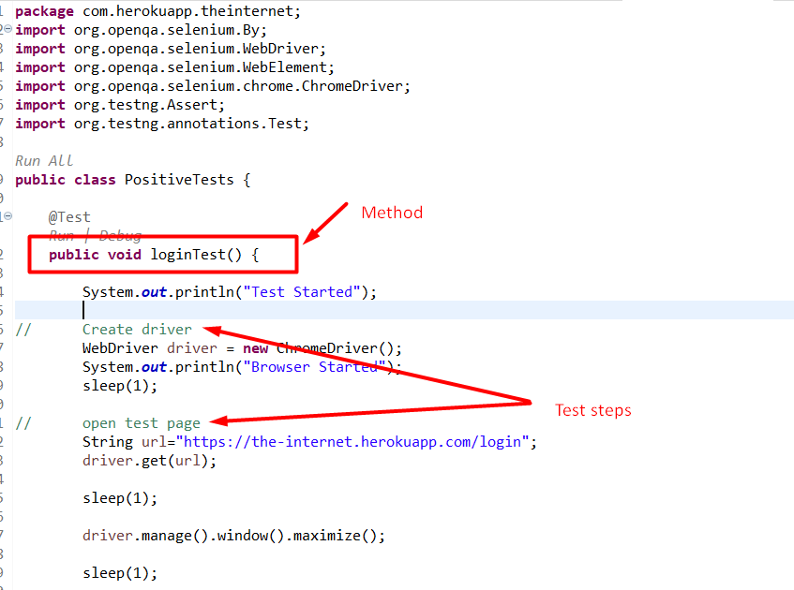

Test steps example:

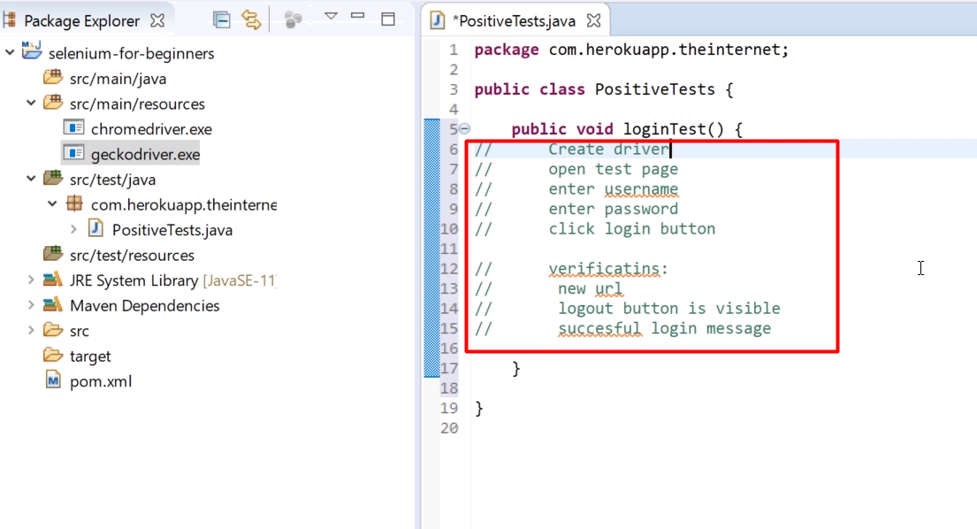

* Import and add driver:

**import** org.openqa.selenium.WebDriver;

**import** org.openqa.selenium.chrome.ChromeDriver;

// Create driver

WebDriver driver = **new** ChromeDriver();

* Open test page:

// open test page

String url="https://the-internet.herokuapp.com/login";

driver.get(url);

* Add **@Test** annotation: To let the project know that the method is a test method we need to mark it with test annotation from testNG.

Import and add test annotation:

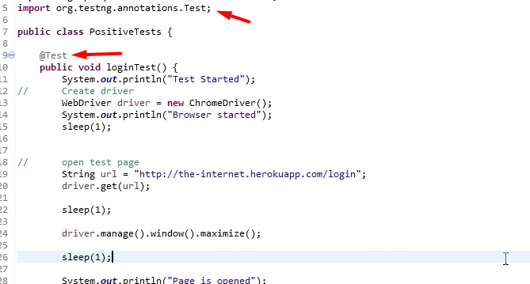

* Close the driver:

driver.close();

**Code to maximize window:**

driver.manage().window().maximize();

Way to set the path to the chrome driver on windows:

System.setProperty(“webdriver.chrome.driver”,”src/main/resources/chromedriver.exe”);

**driver.close():** is used to close the browser or page currently which is having the focus. If the browser has only one tab opened, this command will close the browser. But if there are more the one tab, this command will close only the active tab. This command is useful in test cases where we work with few browser tabs.

**driver.quit():** is used to shut down the web driver instance or destroy the web driver instance. It's a good practice to start a new instance of the driver for each test, and then destroy it at the end of the test. This command will also close the current tab and the browser.

## Running tests with TestNG

### Running tests in cmd

#### Running all the tests at once

* + Go to respective directory:

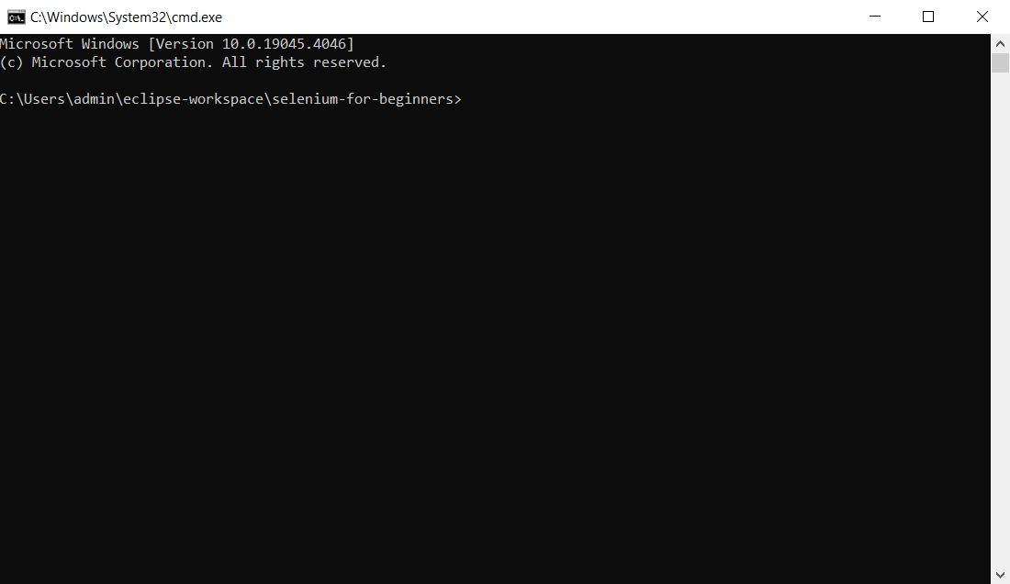

* + Enter command: mvn clean test
* **mvn:** It indicates that the command is a maven command.
* **clean:** This will clean your project before every execution. It will remove maven files generated during last build.
* **test:** starts all test.

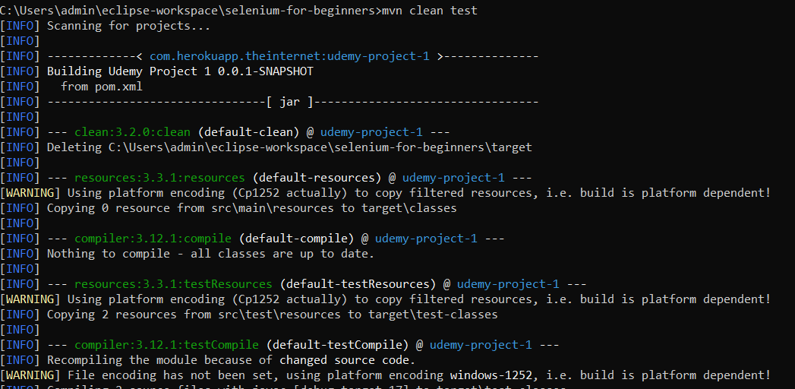

**Test result:** 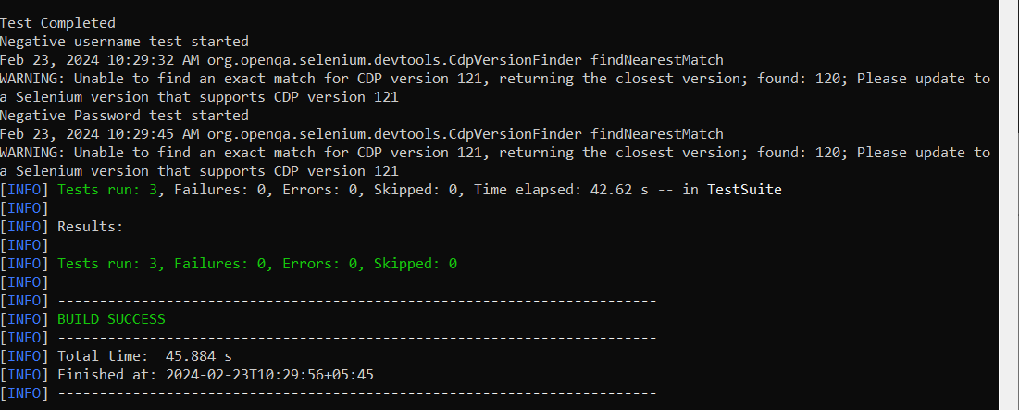

#### Running individual test

* + Enter command: mvn -Dtest=PositiveTests clean test

(Here PositiveTests is the classname)

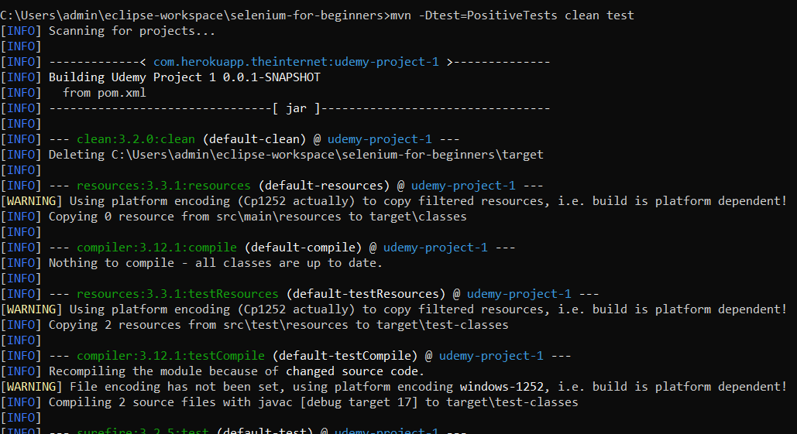

Test result:

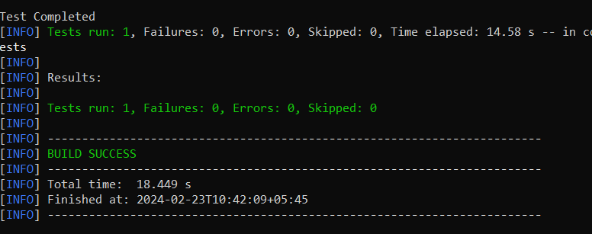

### Running tests in eclipse

* Run configuration.
  + Right click on test class and select run as.
  + Push run configurations.

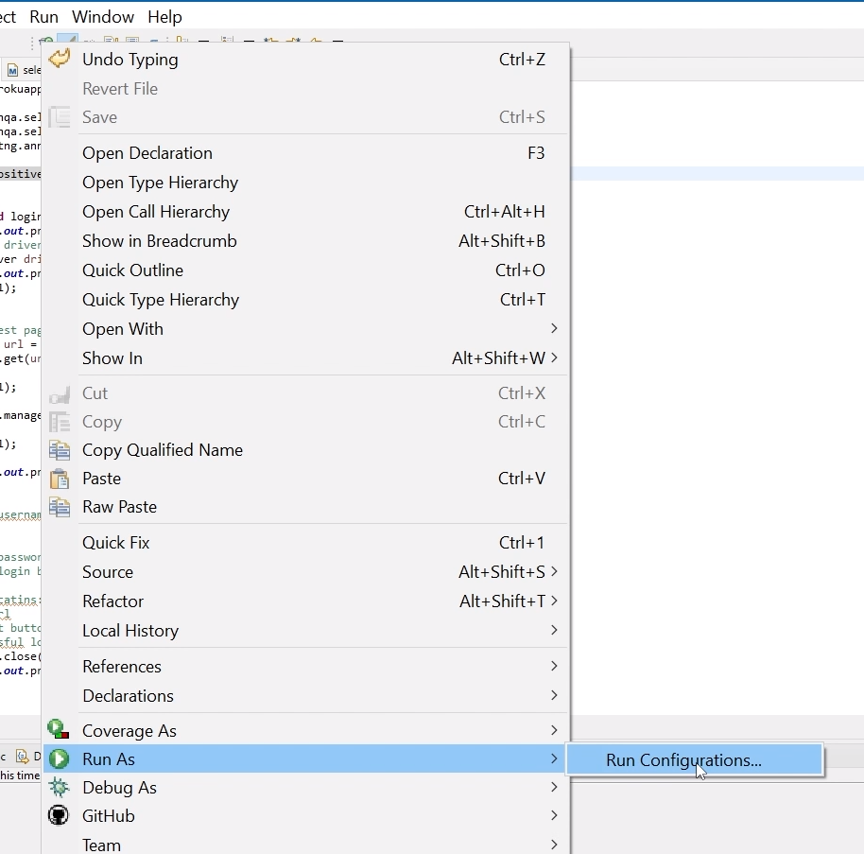

* Create a new run configuration.
  + Double click on Maven Build.
  + And on this configuration window, add the configuration name.
  + For the base directory, click on workspace and just select the project and push.
  + In goals add the command: test clean (Since we are creating Maven build configuration, we don't need to type MVN here, just clean test).
  + To only run the current class: In Goals add: -Dtest=PositiveTests clean test
  + Apply and push run button.

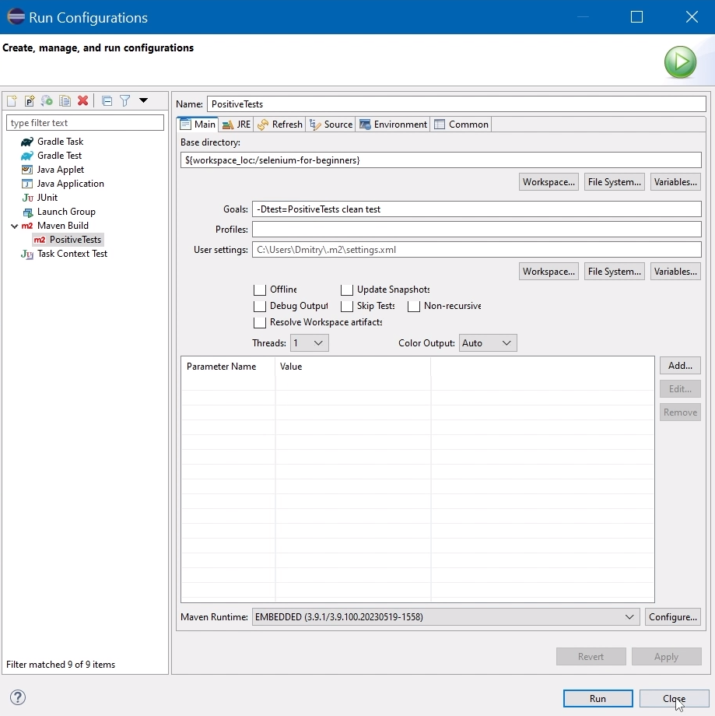

Test result:

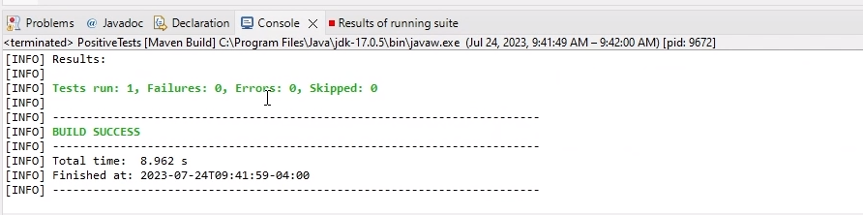

## Identifying page elements and locators

### Elements

* input
* div
* button
* heading tags (h1, h2, h3, h4, h5, h6)
* img
* lists (ul, ol, li)
* link/anchor tag (a)
* tables
* Form controls including radio buttons, edit fields, check boxes, combo boxes, list boxes, and buttons.

### Locators

|  |  |
| --- | --- |
| **Locator** | **Description** |
| class name | Locates elements whose class name contains the search value (compound class names are not permitted) |
| css selector | Locates elements matching a CSS selector |
| id | Locates elements whose ID attribute matches the search value |
| name | Locates elements whose NAME attribute matches the search value |
| link text | Locates anchor elements whose visible text matches the search value |
| partial link text | Locates anchor elements whose visible text contains the search value. If multiple elements are matching, only the first one will be selected. |
| tagname | Locates elements whose tag name matches the search value |
| xpath | Locates elements matching an XPath expression |

### Creating locators with Ranorex Selocity extension

* Add the extension to chrome.

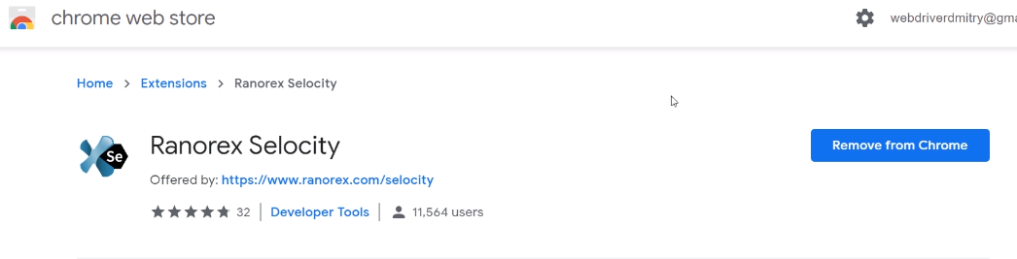

* For css locator:

Right click on the username field and select css from select options and paste it in username field:

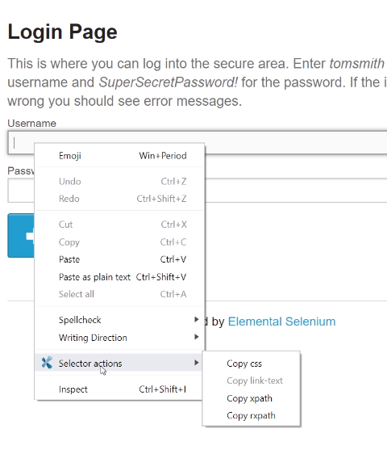

This is how a css locator looks like:

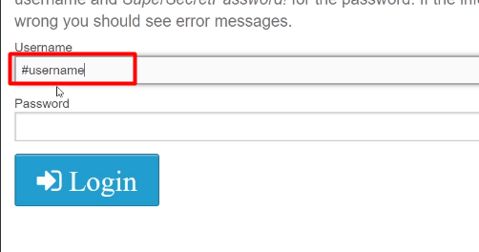

* For xpath locator:

Right click on the password field and select xpath from select options and paste it in username field:



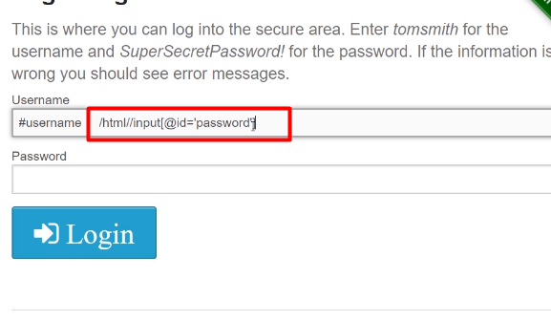

### Creating locators manually

* Right click on username field and click on inspect.
* In dev tools, look at elements tab.
* Observe the attribute of the element.

It has type, name, ID and the ID is the best attribute to use if it's available.

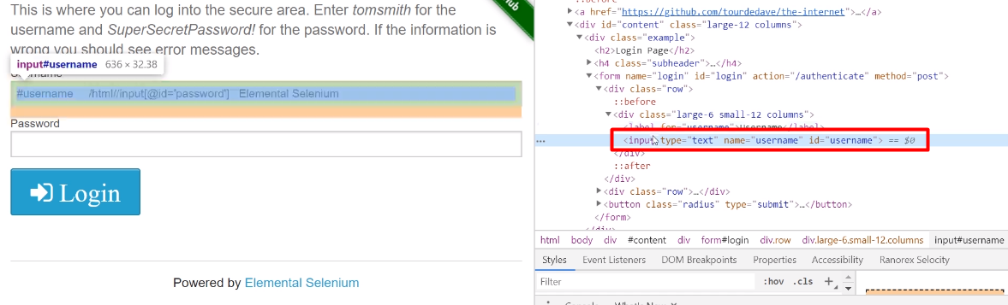

* In chrome dev tools, switch to console tab.
* In console, use the command:

$x(“html//input[@id=’username’]”)[xpath provided by extension]

**Syntax:**



**Tag** can be div, input, button etc and **Attribute** can be id, class, name and the attribute value.

* Again, in console, following the above syntax:

$x("//input[@id='username']");

**Result:**

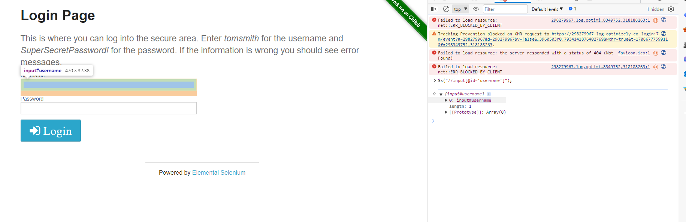

## Introduction to WebElement

For username, password, and login button three web elements are required. Selenium has class WebElement that can be used to store elements in the code.

* For username, password and login button:

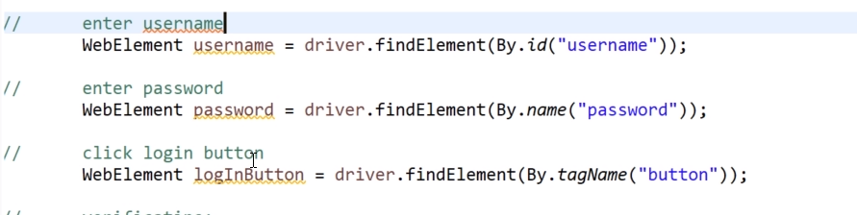

* Import respective classes:

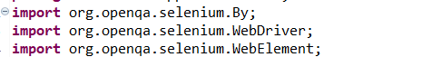

## WebDriver commands in Selenium

We can generally classify Webdriver commands as:

* Browser commands,
* Get commands,
* Navigation commands,
* Webelement commands,
* Action commands and
* Result commands.

Some of the Selenium WebDriver commands are:

* get() methods
* Locating links by linkText() and partialLinkText()
* Selecting multiple items in a drop dropdown
* Submitting a form
* Handling iframes
* close() and quit() methods
* Exception Handling

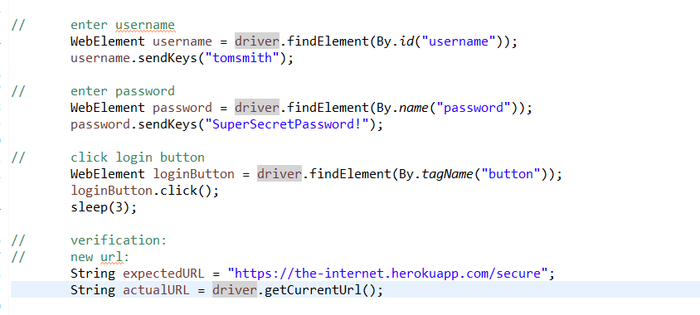

## Implementing Verification and Assertions in Selenium

* Import assert from tenstNG:  
  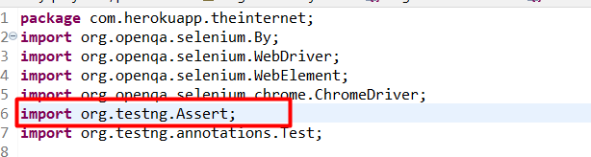
* Implementing the assertEquals method (for url verification):

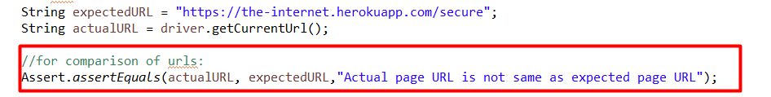

* Implementing the assertTrue method (for button verification):



* Implementing the assertEquals method (for success method verification):

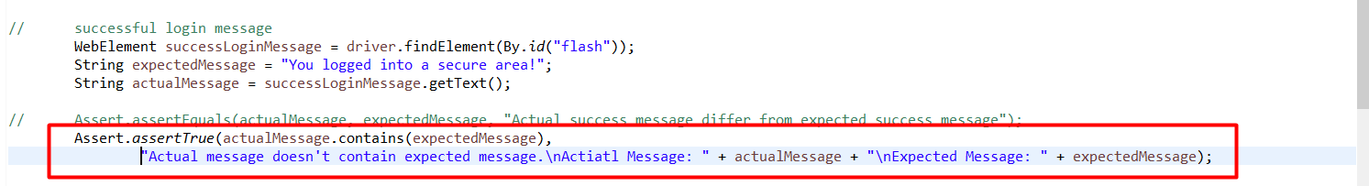

**Questions:**

Q1. Which is the best locator among id, xpath, css, Name?

Ans: Id.

Q2. To open URL with WebDriver, what commands can we use?

Ans: driver. navigate().to() and driver.get() commands.

Q1. Which of following locators we can use for this input element

<input type="text" name="email" id="email">

* By-name("email");
* By.id("email");
* By tagName("input");
* By.xpath("//input[@type='text']");
* We can use all locators.
* None of the locators are correct.

Q2. Where in the maven project we keep test classes?

Ans: src/test/java

Q3. Which of the following is correct way to start chrome driver on Windows PC?

* System. setProperty ("webdriver-gecko.driver","src/main/resources/chromedriver.exe");

WebDriver driver = new ChromeDriver();

* System. setProperty ("webdriver chrome driver","src/main/resources/chromedriver.exe");

WebDriver driver = new ChromeDriver();

* System. setProperty ("webdriver. chrome driver","src/main/resources/chromedriver");

WebDriver driver = new ChromeDriver();

* System. setProperty ("webdriver. chrome driver","src/main/resources/chromedriver.exe");

WebDriver driver = new Chrome();

Q4. What will be the correct command to run tests in the PositiveTests java class from console?

Ans: mvn -Dtest=PositiveTests clean test.

# **Creating and Running Test Suites**

## TestNG Eclipse Plugin for Selenium

**Installation:**

[TestNG for Eclipse | Eclipse Plugins, Bundles and Products - Eclipse Marketplace | Eclipse Foundation](https://marketplace.eclipse.org/content/testng-eclipse)

Guide: [How To Install TestNG In Eclipse: Step-By-Step Guide | LambdaTest](https://www.lambdatest.com/blog/how-to-install-testng-in-eclipse-step-by-step-guide/)

**Running tests using TestNG Eclipse plugin:**

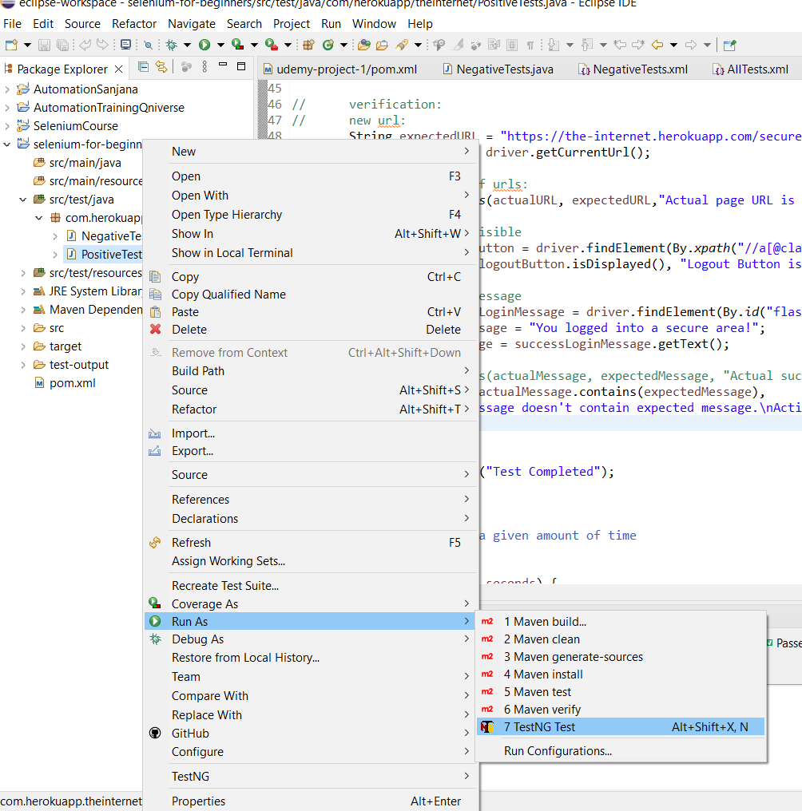

**Result:**

Only necessary information in the console:

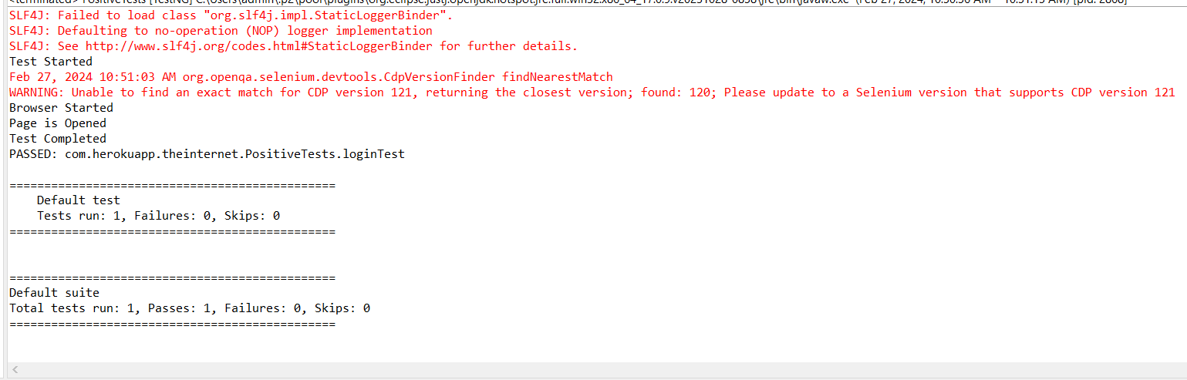

**TestNG plugin tab:**

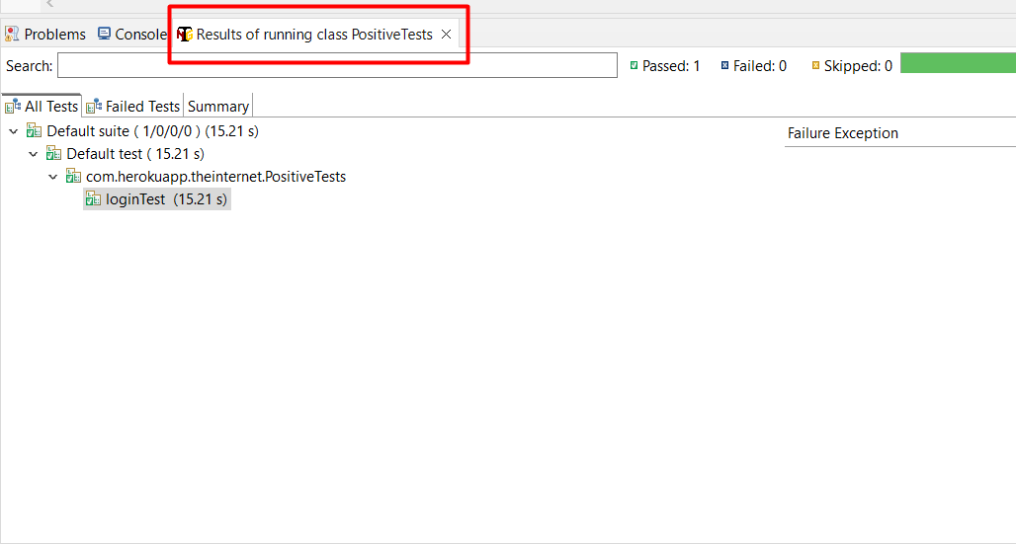

**For error handling:**

Intentionally breaking the code:

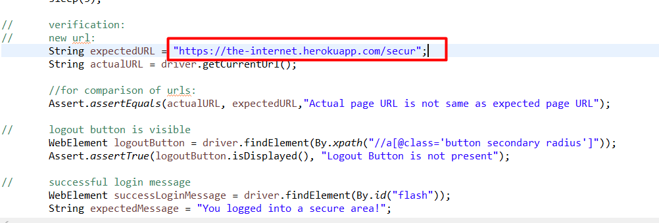

Error generation:

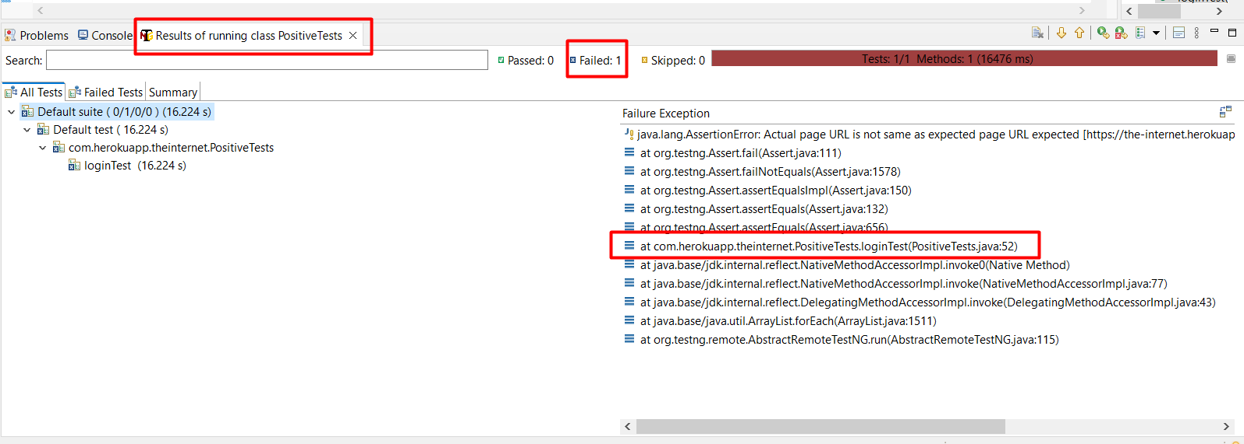

## Negative testing

* Create java class, Negative tests:

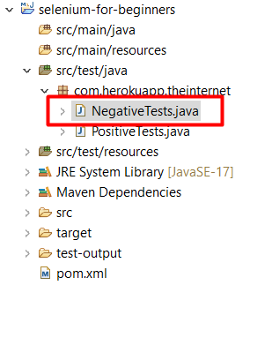

* Create method, write test steps and create web elements and locators for incorrect username:

**public** **void** incorrectUsernameTest() {

System.***out***.println("Negative username test started");

// Start the browser

WebDriver driver = **new** ChromeDriver();

// Go to the website via url

String url = "https://the-internet.herokuapp.com/login";

driver.get(url);

driver.manage().window().maximize();

// locate username field

// input username

WebElement username = driver.findElement(By.*id*("username"));

username.sendKeys("incorrect");

// locate password field

// input password

WebElement password = driver.findElement(By.*id*("password"));

password.sendKeys("SuperSecretPassword!");

// locate login button

// click on login button

WebElement loginButton = driver.findElement(By.*xpath*("//button[@class='radius']"));

loginButton.click();

// verification:

// test error message

WebElement errorMessage = driver.findElement(By.*id*("flash"));

String expectedErrorMessage = "Your username is invalid!";

String actualErrorMessage = errorMessage.getText();

Assert.*assertTrue*(actualErrorMessage.contains(expectedErrorMessage),

"Actual message doesn't contain the expected error message. " + "\nActual: " + actualErrorMessage

+ "\nExpected: " + expectedErrorMessage);

// Close browser

driver.quit();

}

* By following the same process, create method, write test steps and create web elements and locators for incorrect password:

**public** **void** incorrectPasswordTest() {

System.***out***.println("Negative Password test started");

// Start the browser

WebDriver driver = **new** ChromeDriver();

// Go to the website via url

String url = "https://the-internet.herokuapp.com/login";

driver.get(url);

driver.manage().window().maximize();

// locate username field

// input username

WebElement username = driver.findElement(By.*id*("username"));

username.sendKeys("tomsmith");

// locate password field

// input password

WebElement password = driver.findElement(By.*id*("password"));

password.sendKeys("incorrectpassword");

// locate login button

// click on login button

WebElement loginButton = driver.findElement(By.*xpath*("//button[@class='radius']"));

loginButton.click();

sleep(3);

// verification:

// test error message

WebElement errorMessage = driver.findElement(By.*id*("flash"));

String expectedErrorMessage = "Your password is invalid!";

String actualErrorMessage = errorMessage.getText();

Assert.*assertTrue*(actualErrorMessage.contains(expectedErrorMessage),

"Actual message doesn't contain the expected error message. " + "\nActual: " + actualErrorMessage

+ "\nExpected: " + expectedErrorMessage);

// Close browser

driver.quit();

}

* Run using testNG plugin:

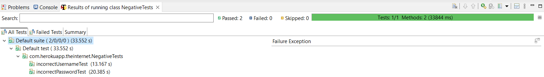

## Building TestNG Test Suite

We have now three tests in two different test classes, and you know how to run tests inside of one class, but we can combine tests from different classes and run them together. To do so, we will be using TestNG tests with xml files.

* Go to: [TestNG Documentation](https://testng.org/#_testng_xml)

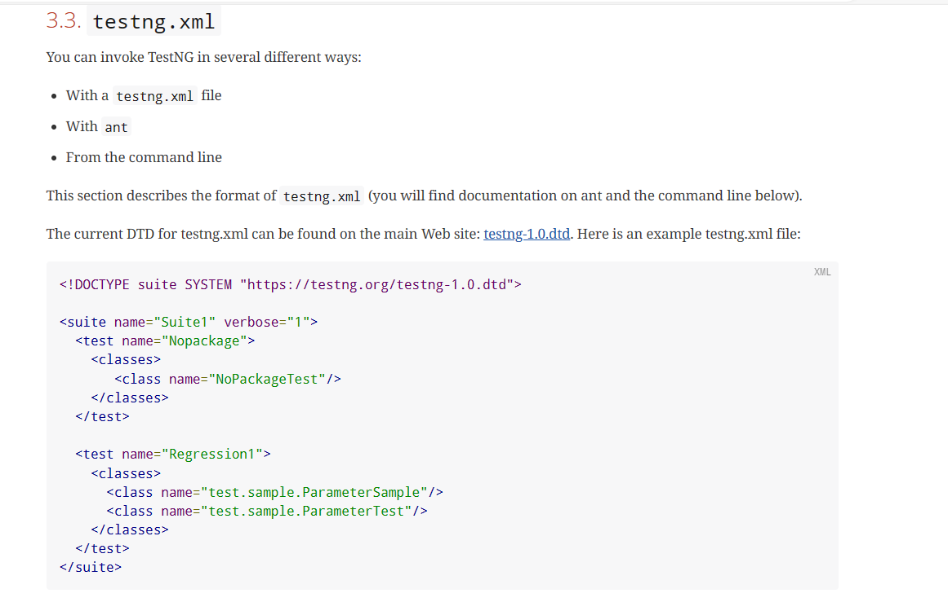

* Copy the above example.
* Under src/test/resources, create a new folder called TestSuites.
* In the folder create a new file: AllTests.xml and past the copied example:

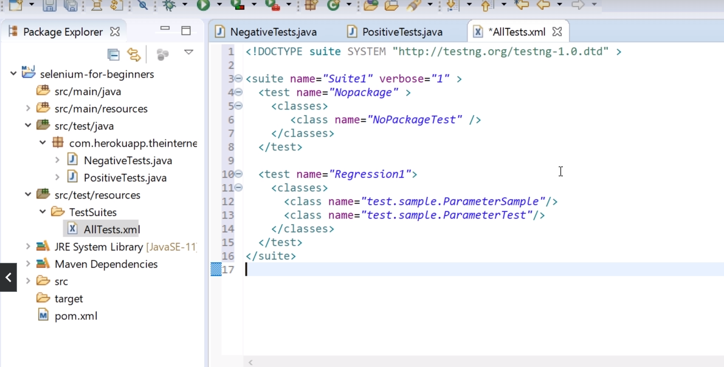

* Let Maven know that we want to run tests using TestNG suite files first:
  + Open pom.xml
  + Srcoll to Maven Surefire plugin
  + Inside the Maven surefire plugin, replace the default suiteXmlFile i.e, testing.xml with location of AllTests.xml.

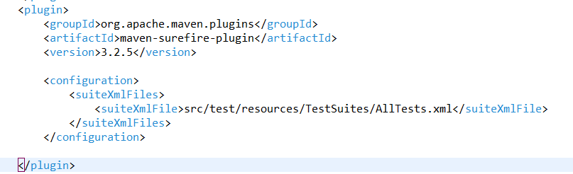

* + Change the AllTests.xml file accordingly:

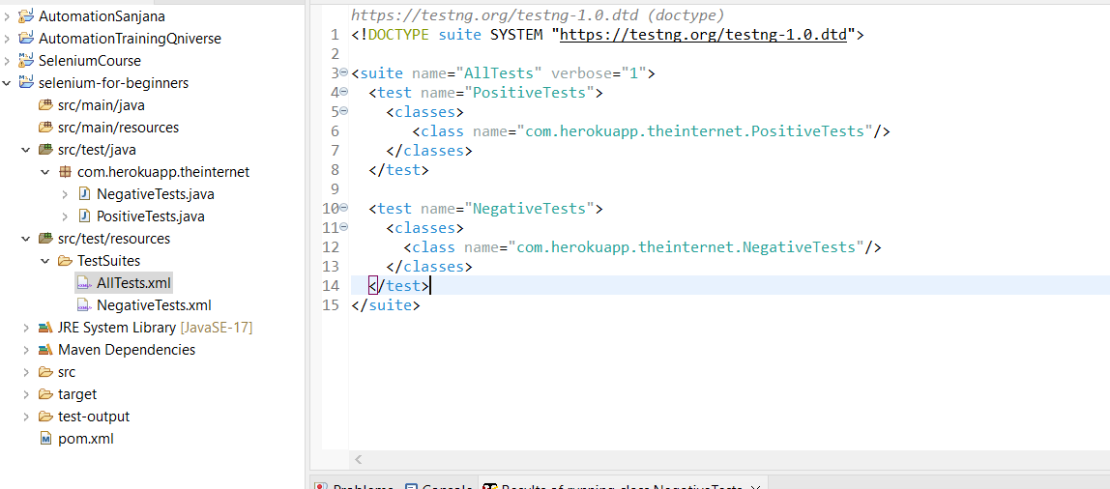

## Running TestNG Test Suite

* Right click on AllTests.xml file
* Click on run as and select the testNG suite to run:

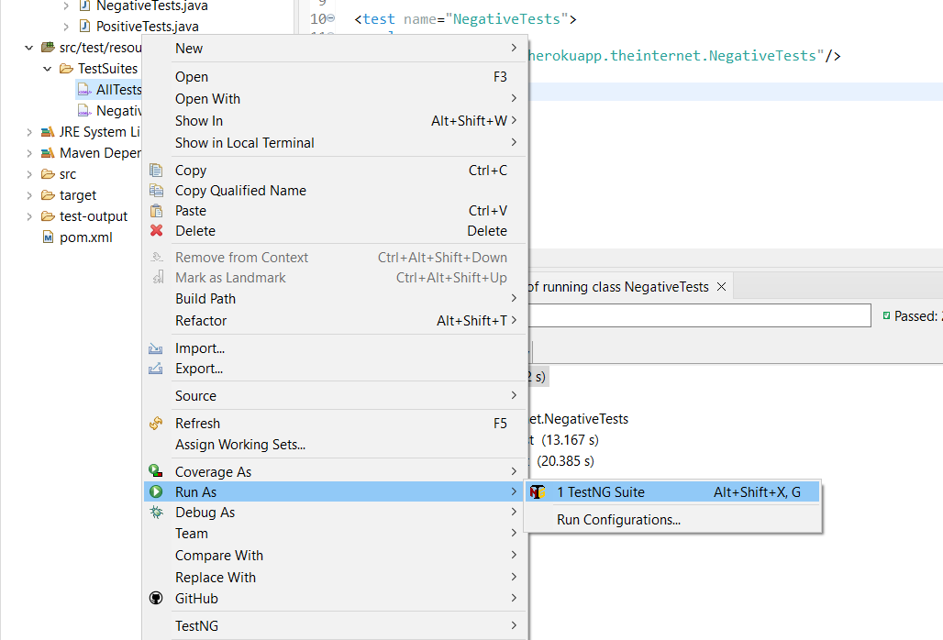

* Test result:

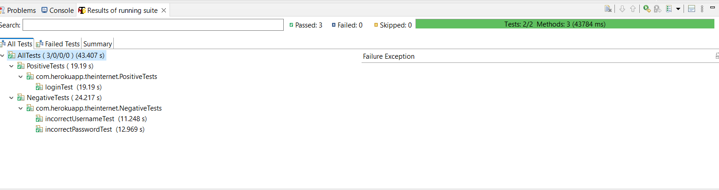

# **Benefits of TestNG Framework**

## Parameters from TestNG documentation

### Priority parameter

TestNG run tests in alphabetical order. We can use parameters for @Test annotation to prioritize test execution order. We can use parameter called priority for our tests and test with higher priorities will be scheduled first.

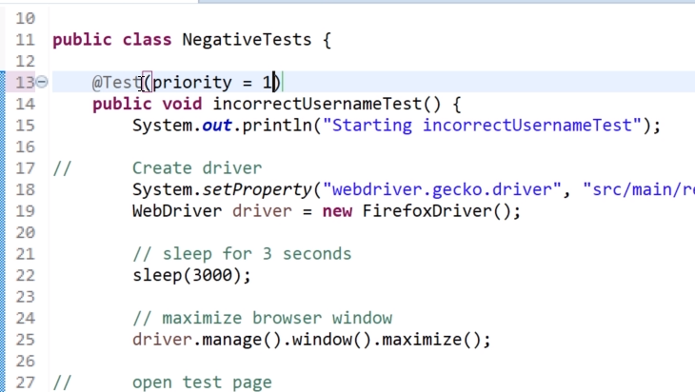

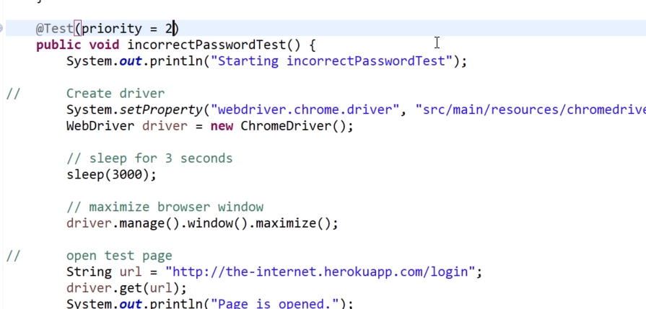

Now on successful execution, test with priority 1 will be executed first.

### Enabled parameter

In a large test automation project, particularly during new releases, it's not uncommon to encounter broken tests that we anticipate will fail. However, due to time constraints, immediate fixes aren't always feasible. Despite this, it's essential to conduct regression tests for the new release efficiently, without being hindered by known issues.

To address this, we implement a strategy to selectively disable these problematic tests, ensuring they don't impede the regression testing process. Once disabled, we prioritize fixing them at a more convenient time. Once resolved, we seamlessly re-enable them to ensure comprehensive test coverage moving forward. This approach allows us to maintain testing integrity while efficiently managing and addressing known issues within our test suite.

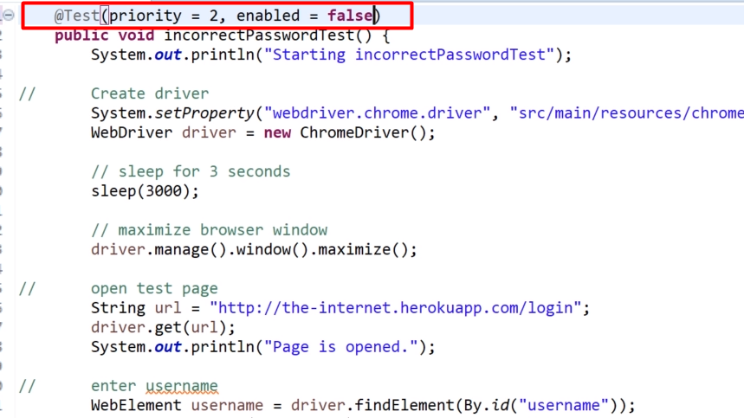

## Organizing Tests with TestNG Groups

Grouping tests is highly beneficial for organizing and managing test suites effectively. TestNG offers a feature where you can assign one or more groups to individual tests, providing flexibility in test execution.

By assigning groups to tests, you gain the ability to include or exclude specific groups during test execution. This allows for targeted testing based on criteria such as functionality, priority, or specific requirements.

TestNG's capability to include or exclude groups during test execution enhances test suite flexibility, enabling testers to focus on relevant test scenarios and streamline the testing process efficiently.

We use groups when we have lots of tests.

Let’s create groups:

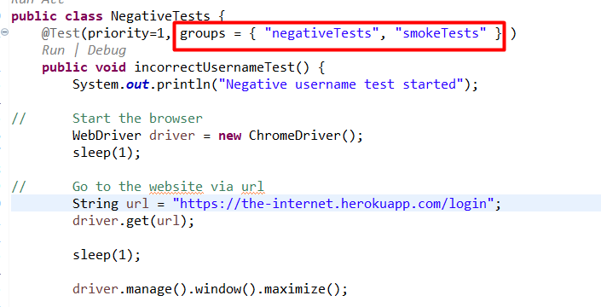

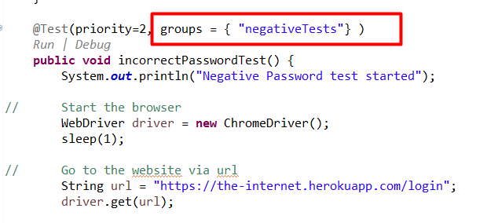

In the above images, we can see that incorrectPasswordTest() only belongs to negativeTests group and not smokeTests group.

Now, Let’s create NegativeTests.xml suite file to execute only negative tests:

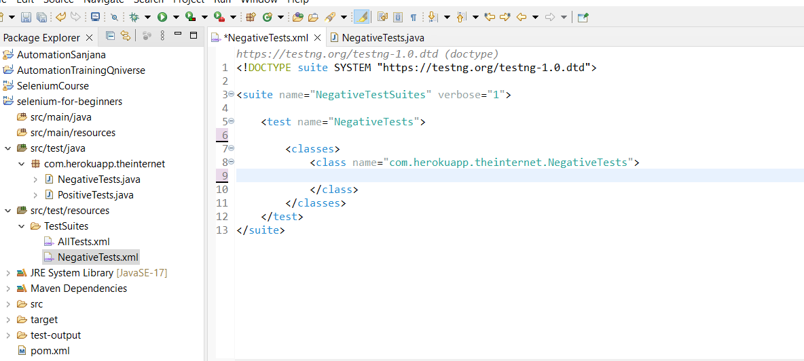

To run tests for group smokeTests, update the suite as:

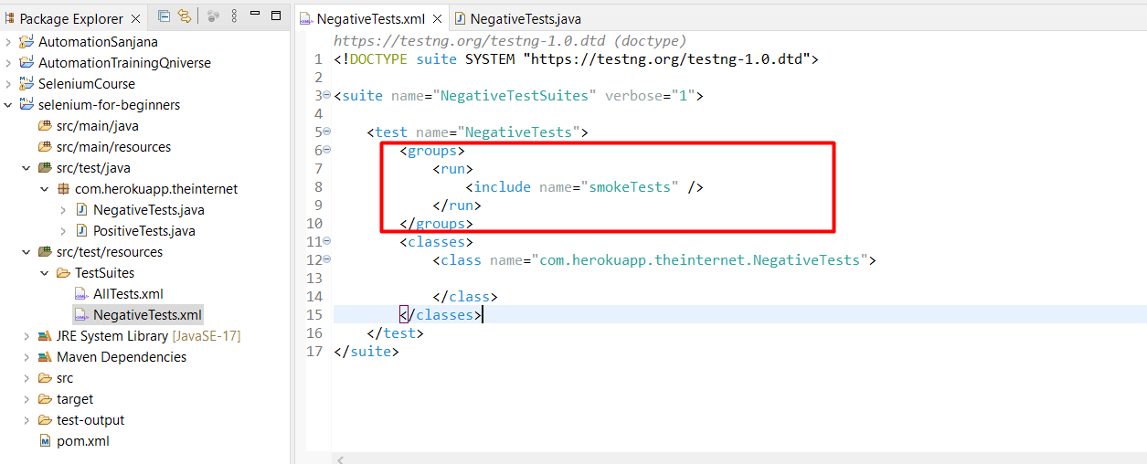

## Include or exclude specific test methods.

When dealing with a class containing 10 methods, the approach to test selection can vary based on the specific scenario.

If the intention is to execute nine out of the ten methods, excluding one would be the logical choice. This simplifies the process by specifying which method to exclude, ensuring that the remaining nine are executed without unnecessary complexity.

Conversely, if the requirement is to run just one method from the class, it's more straightforward to include that particular method for execution. In this case, specifying the method to include ensures that only the desired test is executed, avoiding the need to list all other methods to be excluded.

For instance, if the goal is to include the second test method, the focus would be on specifying this method for execution, simplifying the test selection process and ensuring that only the intended test is run.

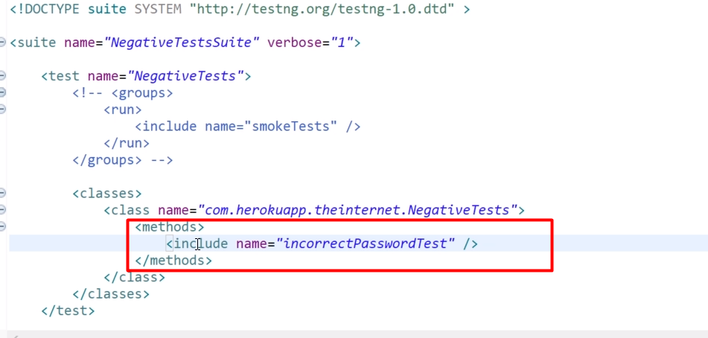

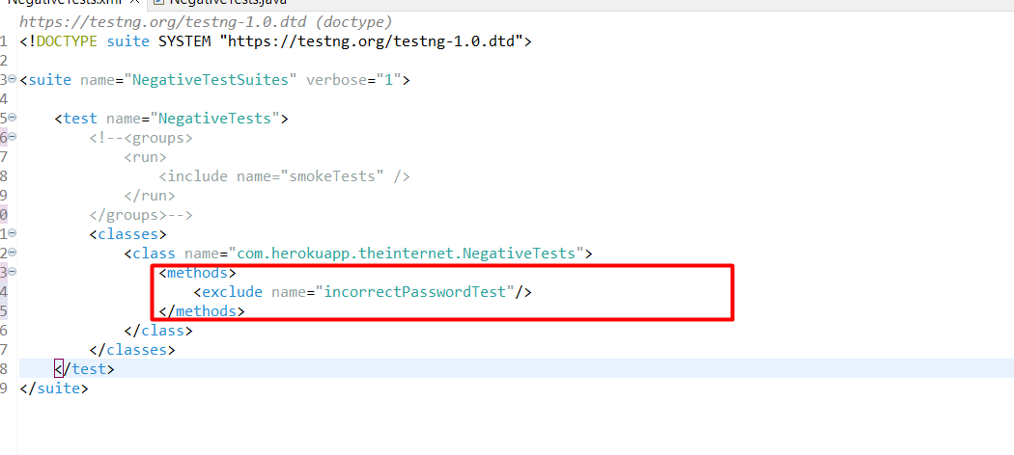

When including or excluding specific test method names, it's imperative to confirm that the designated test class indeed contains these methods. Otherwise, the selection process becomes nonsensical and ineffective.

Now that you're acquainted with various approaches for including or excluding tests, let's summarize:

* Utilize the enable parameter to enable or disable specific test methods.
* Organize tests into groups and execute selected groups as needed.
* Employ the option to include or exclude particular test methods directly within the test suite XML file.

By employing these methods, you gain precise control over test execution, ensuring efficiency and accuracy in your testing procedures.

## Parameters from test suite.

At times, running tests with externally sourced data proves beneficial, and the "@Parameters" annotation facilitates the passage of parameters to a test method. This serves as the foundational step toward establishing a data-driven test framework. Rather than relying on spreadsheets or databases for test data, the "@Parameters" annotation offers a convenient alternative, particularly suitable for scenarios involving a limited number of straightforward parameters.

We can enhance our tests by addressing redundancy in our code. Let's examine our "NegativeTests" class, which contains two tests: "incorrectUsernameTest" and "incorrectPasswordTest". The steps within these tests are nearly identical: we navigate to the page, input username and password, differing only in the entry of an incorrect username for the first test and an incorrect password for the second. Subsequently, we click the login button and retrieve the error message text for comparison with the expected error message.

Given this similarity, it's advantageous to avoid hardcoding values into the code. Instead, we can define these values in the testng.xml file and employ a single test method to execute both scenarios: one for an incorrect username and the other for an incorrect password. This approach not only streamlines our code but also promotes easier maintenance in the future. For instance, if we encounter a new login page requiring adjustments to our automated tests, we'll only need to modify a single test method rather than two separate ones. This consolidation ensures better code management and reduces the effort required for future maintenance tasks.

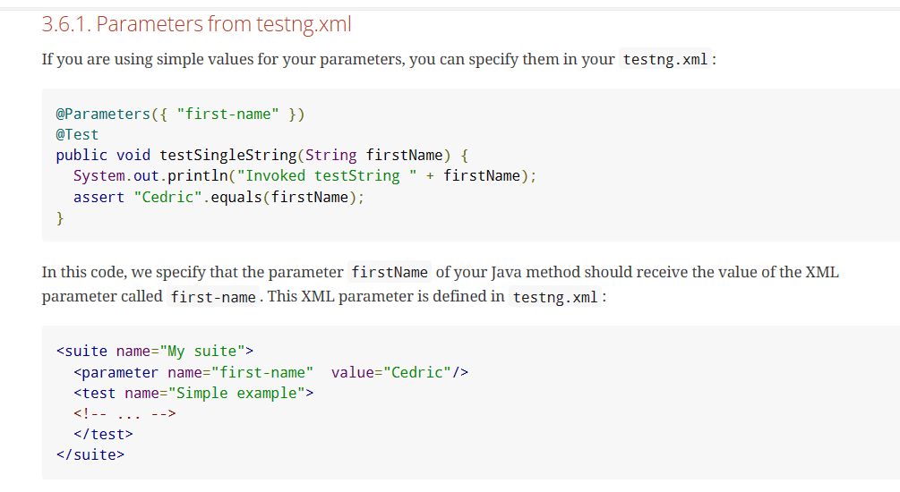

In the example provided in the test documentation, our test method can receive a parameter. Essentially, we specify the parameter name that our test method should accept, and it receives this parameter, in this case, as a String example.

In our test suite, we simply indicate that for this specific test case, we have parameters named "first-name", and here's the parameter "first-name" with the assigned value, such as "Cedric".

Consequently, our test method remains unchanged, but within our test suite, we have the flexibility to assign different values to the "first-name" parameter, effectively modifying the behavior of the test.

Let's apply this approach in our case. Initially, we'll move our variables to the TestNG suite file. Within our negative test suite, we'll have two tests: one for negative username and another for negative password.

Firstly, let's rename the existing test to "negative username test" and remove unnecessary elements such as groups and exclusions. Next, let's add parameters by referencing the example provided in our test documentation. We'll define three parameters: "username", "password", and "expectedMessage". It's essential to maintain consistency by naming them all in lowercase: "username", "password", and "expectedMessage".

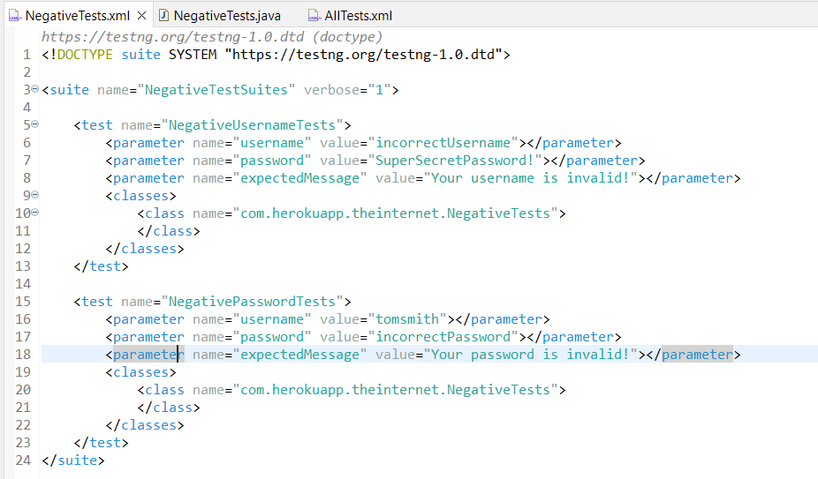

In NegativeTest.java class, the two methods should be combined in one. For this let’s comment out one of the two test. And rename the method name to be negativeLoginTest.

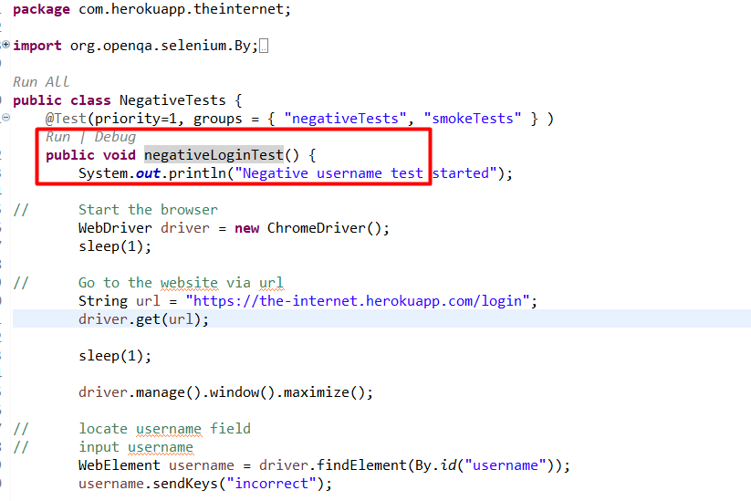

Now. Let’s add @parameters annotation to this test to receive parameters from NegativeTests.xml file.

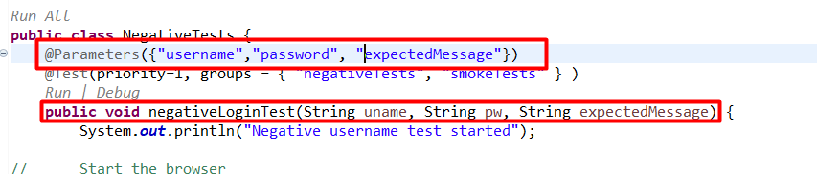

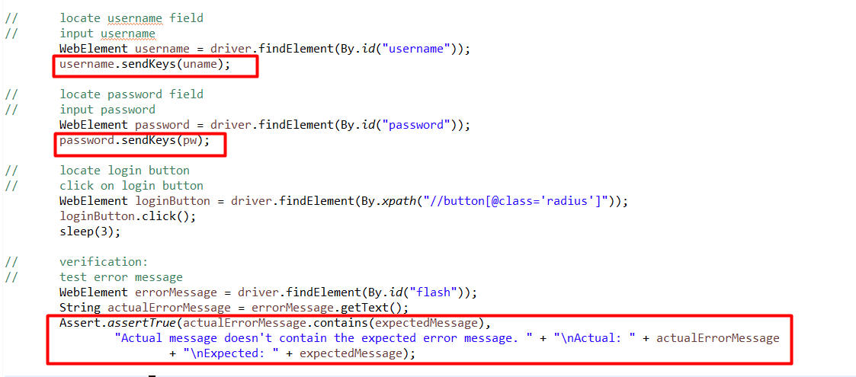

## Combining Login Tests in Selenium.

We can enhance our project by consolidating our negative and positive login tests into a single "LoginTest" class. This approach offers several advantages, primarily improving organization and readability. By grouping tests that operate on the same page or share similar steps into the same test class, we establish a logical structure that simplifies maintenance and navigation.

Previously, we separated positive tests into one class and negative tests into another. However, it's more effective to unite them within a single class, especially since we've learned how to utilize groups. We can now place all login-related tests in the "LoginTest" class and categorize them accordingly. Tests that validate positive login scenarios will be marked with the "positive" group, while those assessing negative login scenarios will be labeled with the "negative" group.

This consolidation streamlines our test suite, promoting cohesion and ease of management. Additionally, it fosters better collaboration among team members by providing a clear overview of all login-related tests within a single class.

The LoginTest class structure will look like:

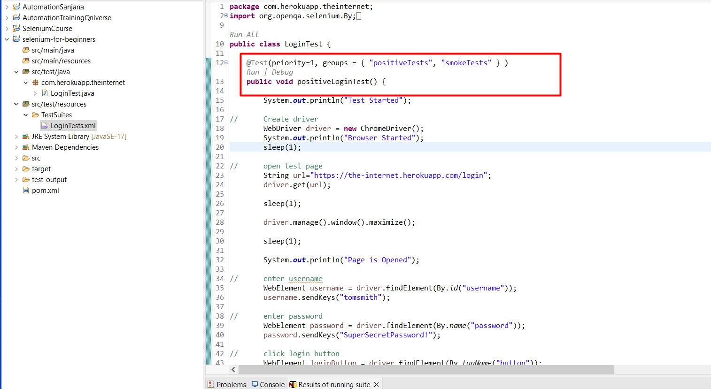

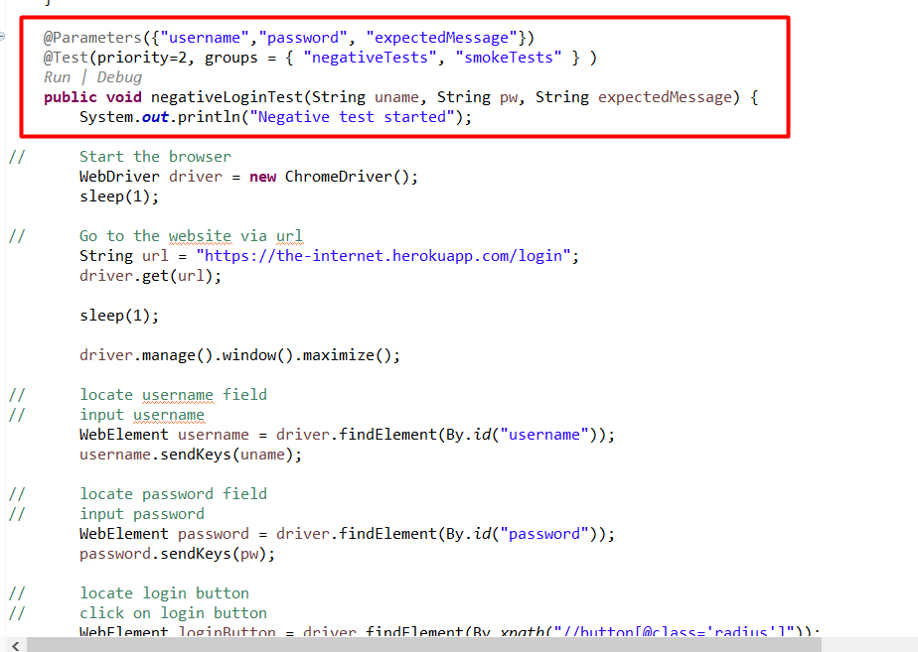

Updating the xml file and renaming with LoginTests.xml:

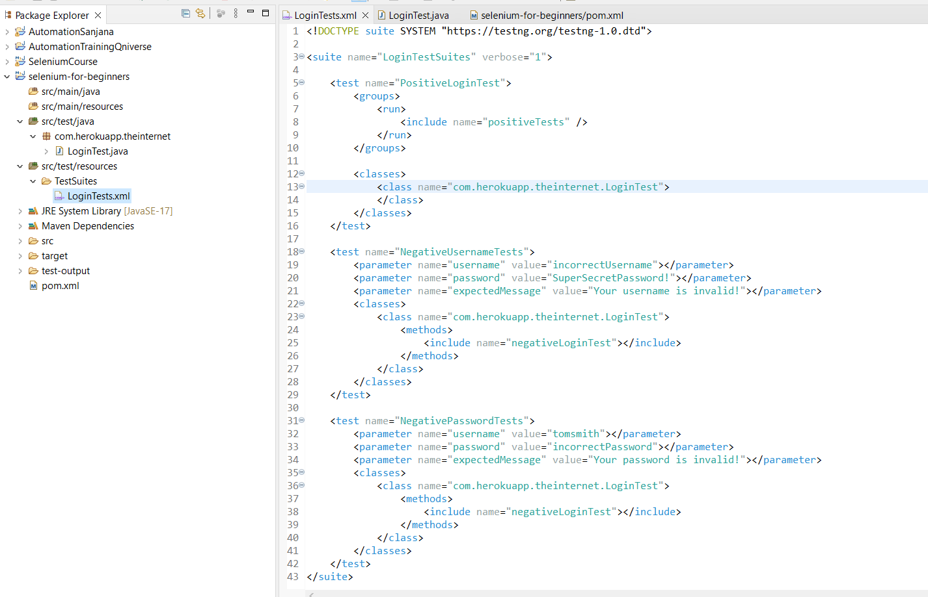

## Using TestNG Before and After Annotations.

"@Before" and "@After" are two crucial annotations. These annotations enable us to configure when to run methods that are not marked with the "@Test" annotation.

For instance, using "@BeforeSuite" ensures that a method is executed once before the entire test suite runs. Conversely, "@AfterMethod" runs a method after each test method within the suite.

In our project, we're streamlining our tests by consolidating repetitive setup and teardown steps. Instead of duplicating these steps in every test method, we're creating a single "setup" method to initialize the browser driver and a "teardown" method to close the browser. We'll annotate these methods with "@BeforeMethod" and "@AfterMethod", respectively, to ensure they're executed before and after each test method.

### @BeforeMethod implementation with setup method

**private** WebDriver driver;

@BeforeMethod

**private** **void** setUp() {

System.***out***.println("Test Started");

// Create driver

driver = **new** ChromeDriver();

System.***out***.println("Browser Started");

sleep(1);

driver.manage().window().maximize();

sleep(1);

// open test page

String url="https://the-internet.herokuapp.com/login";

driver.get(url);

System.***out***.println("Page is Opened");

sleep(1);

}

### Issue with BeforeMethod:

However, we encountered an issue with the "@BeforeMethod" not being executed due to group restrictions. To resolve this, we added the "alwaysRun = true" parameter to ensure it's executed regardless of the test groups.

**private** WebDriver driver;

@BeforeMethod(alwaysRun=**true**)

**private** **void** setUp() {

System.***out***.println("Test Started");

// Create driver

driver = **new** ChromeDriver();

System.***out***.println("Browser Started");

sleep(1);

driver.manage().window().maximize();

sleep(1);

// open test page

String url="https://the-internet.herokuapp.com/login";

driver.get(url);

System.***out***.println("Page is Opened");

sleep(1);

}

Similarly, we extracted the teardown steps into a separate method and annotated it with "@AfterMethod" along with "alwaysRun = true" to ensure it's executed after each test method, irrespective of the test groups.

### @AfterMethod implementation with teardown method:

@AfterMethod

**private** **void** tearDown((alwaysRun=**true**)) {

// Close browser

driver.quit();

System.***out***.println("Test Completed");

}

This approach improves code efficiency by reducing duplication and ensuring consistent setup and teardown procedures across all test methods. Let's run our tests again to verify that everything is functioning correctly.

## Cross Browser Testing with Selenium and TestNG.

In our setup method, we instantiate our browser instance, which is then utilized throughout our tests. Presently, we're confined to executing all tests in the browser defined here, ChromeDriver. While we could manually switch browsers by modifying the code, doing so before each run is cumbersome and error prone.

A more efficient approach is to leverage parameters, akin to how we employ them for our negative tests. By specifying the browser in the test suite, we gain the flexibility to run specific tests in different browsers without altering the code.

For instance, in our test suite XML file, we can define a parameter indicating the desired browser for execution. This parameter can accept values such as "Chrome" or "Firefox", allowing us to customize the browser dynamically for each test run.

Implementing this approach not only streamlines browser configuration but also enhances test flexibility and maintainability. It eliminates the need for manual code modifications, ensuring smoother test execution across different browser environments. Let's proceed with integrating this parameterization into our test suite configuration.

@Parameters({"browser"})

@BeforeMethod(alwaysRun=**true**)

**private** **void** setUp(String browser) {

System.***out***.println("Test Started");

// Create driver

**switch** (browser) {

**case** "chrome":

driver = **new** ChromeDriver();

System.***out***.println("Browser Started");

**break**;

**case** "firefox":

driver = **new** FirefoxDriver();

System.***out***.println("Browser Started");

**break**;

**default**:

System.***out***.println("Chrome brower started instead");

driver = **new** ChromeDriver();

System.***out***.println("Browser Started");

**break**;

}

sleep(1);

driver.manage().window().maximize();

sleep(1);

// open test page

String url="https://the-internet.herokuapp.com/login";

driver.get(url);

System.***out***.println("Page is Opened");

sleep(1);

}

In LoginTests.xml file, add parameter and set value:

<parameter name="browser" value="firefox"></parameter>

Add the above parameter for PositiveLoginTest and NegativeUsernameTests.

<parameter name="browser" value="chrome"></parameter>

And this for NegativePasswordTest.

**Test result:**

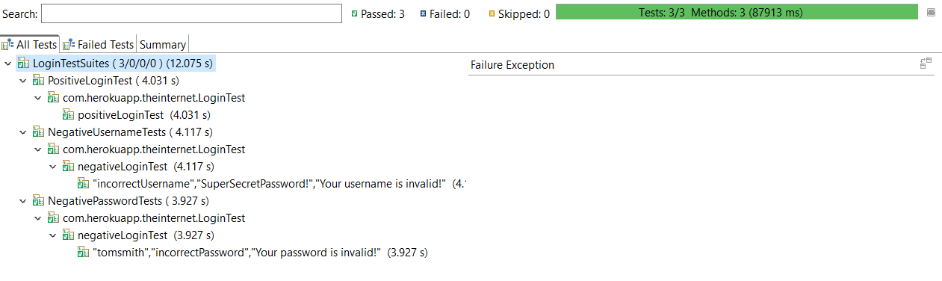

# **Debugging common test failures**

## Debugging Techniques for Selenium WebDriver Tests

In software testing, encountering failures is common, but effectively debugging these failures is crucial for maintaining the stability and reliability of test suites.

To demonstrate how to debug tests step by step, let’s intentionally break one of the tests by modifying a locator.

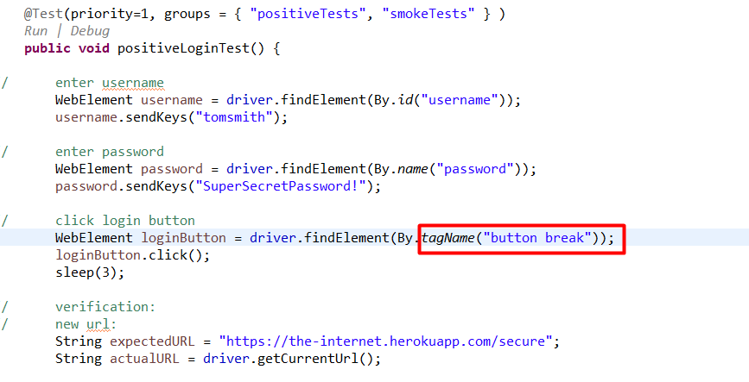

Then, let’s create a new test suite file containing only the affected test.

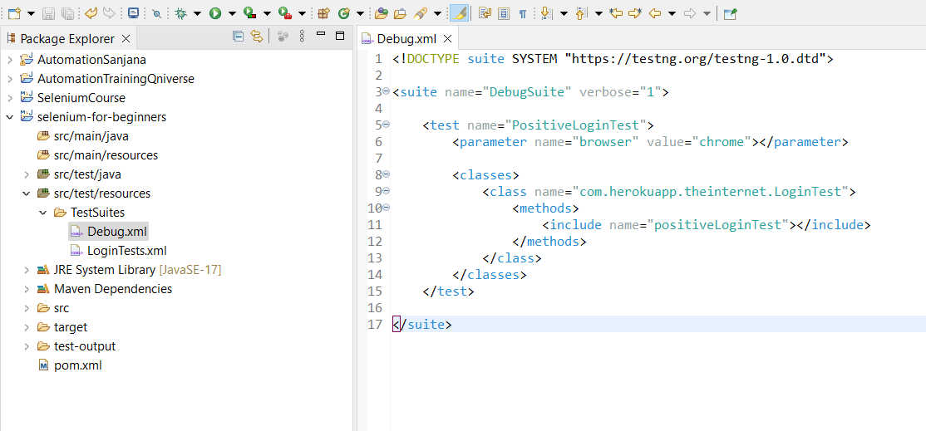

Running this test suite results in a failure, which we analyze by examining the error message and stack trace to identify the exact line where the failure occurred.

In console:

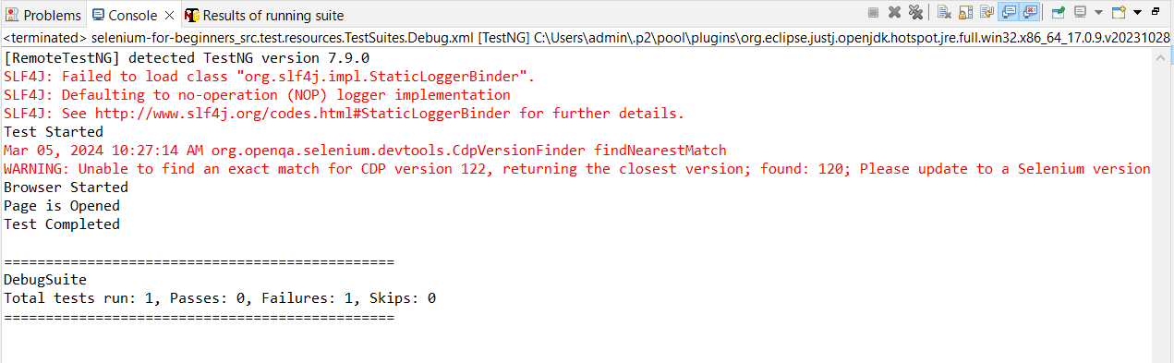

Results of TestNG Suite:

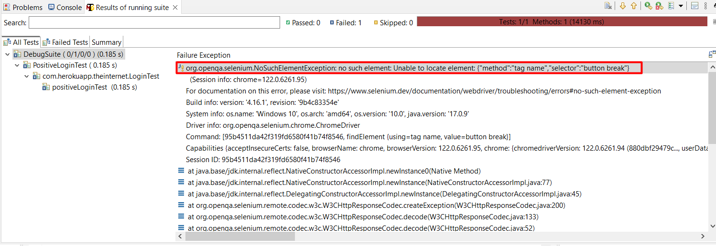

Error detected with the help of package:

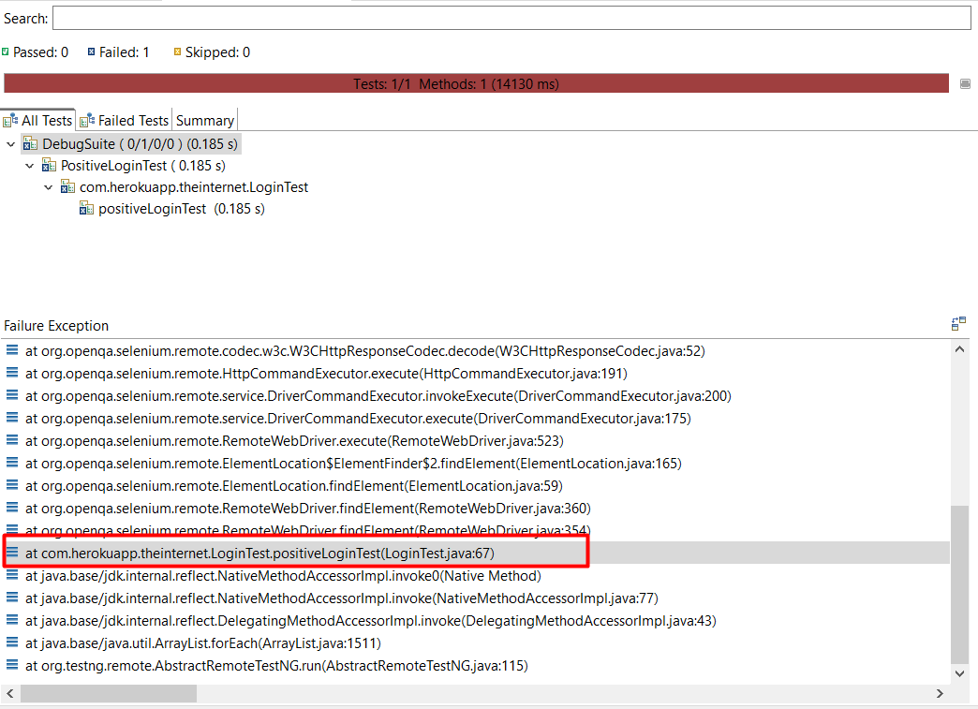

Double click and get redirected to the error in code:

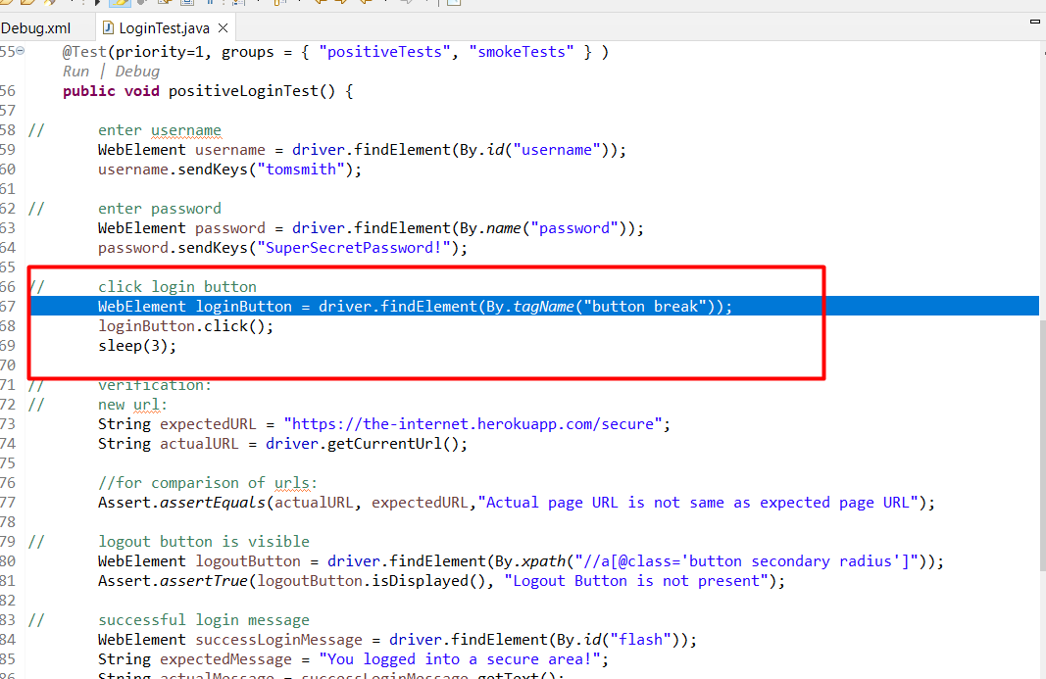

In our scenario, identifying the problem is straightforward due to the error message indicating that there is no such element. From the stack trace, we can determine the exact element causing the issue. However, troubleshooting test failures may not always be as clear-cut, and in such cases, debugging the test step by step can provide valuable insights.

To initiate the debugging process, we right-click on our debug XML file and select "Debug" instead of "Run." Then, we choose "TestNG Suite" to debug the entire test suite or "Test" to debug individual tests within the suite. This initiates the test execution in debug mode, causing the execution to halt at the breakpoints set in the code.

Debugging allows us to pause the execution at critical points, enabling us to inspect variables, step through the code line by line, and analyze the program's behavior in real-time. This granular approach helps identify the root cause of the failure and understand the flow of the test execution.

By leveraging debugging capabilities, testers can gain deeper insights into the test execution process, diagnose complex issues, and effectively troubleshoot test failures, ultimately improving the overall quality of the testing process.

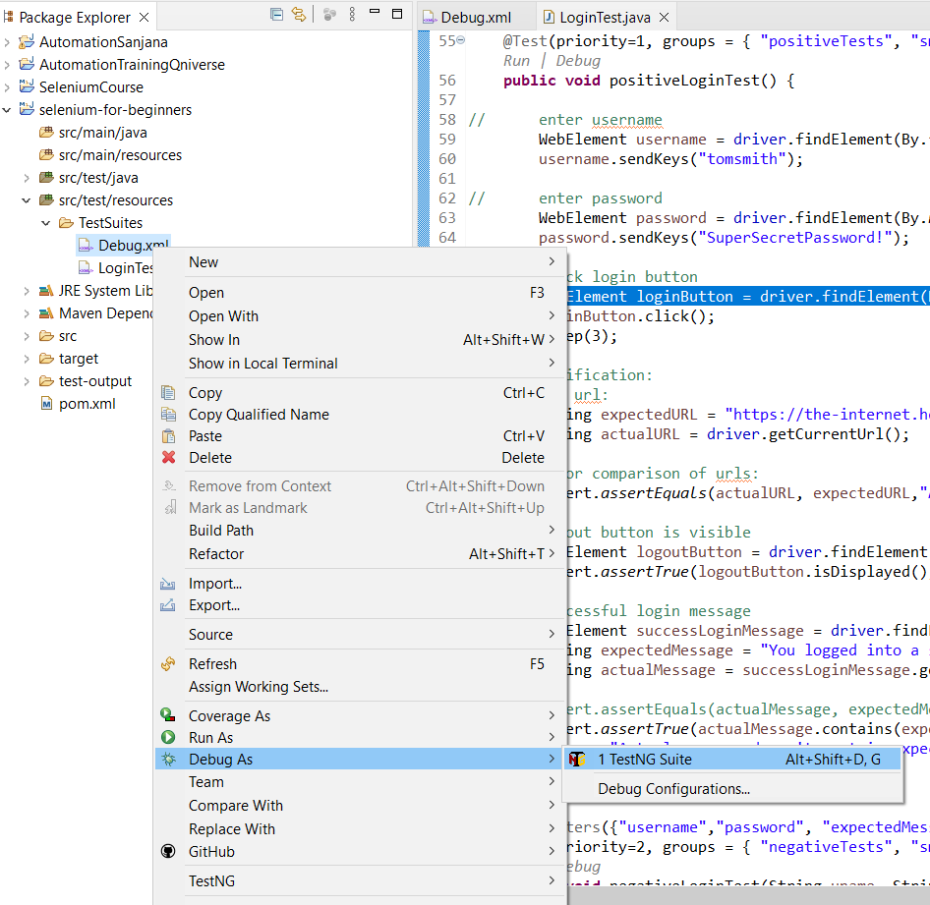

To debug the test, let’s set breakpoints in the code at specific lines where we want the execution to pause. (You can also double click to the left to add or remove breaking points)

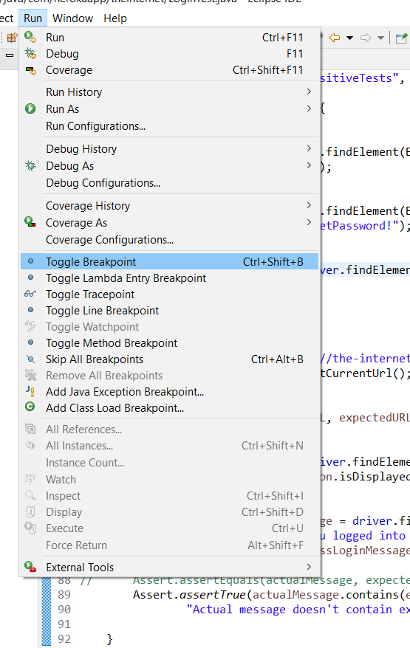

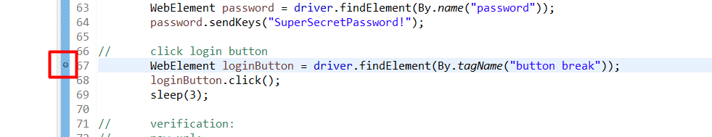

Now, let’s run the test in debug mode, which allows us to step through the code one line at a time. There are various buttons available in the debug perspective, such as step into, step over, and resume, which help navigate through the code during debugging.

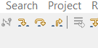

Step-return

Step-into

Step-over

### Step Into:

The "step-into" command allows the debugger to enter into the next line of code, including any method calls or function invocations. If the current line of code contains a method call, "step-into" will enter that method and pause the execution at the first line of code within the method. This command is useful for tracing the flow of execution into different methods or functions to understand their behavior.

### Step Over:

The "step-over" command allows the debugger to execute the current line of code and move to the next line without entering into any method calls or function invocations on that line. If the current line of code contains a method call, "step-over" will execute the entire method call as a single step without entering into its internal implementation. This command is useful for quickly progressing through the code while skipping over method calls that are not relevant to the debugging process.

### Step Return:

The "step-return" command allows the debugger to execute the remaining lines of code within the current method or function and then return to the caller of that method or function. It essentially steps out of the current method or function and resumes execution at the line of code immediately after the method call. This command is useful for quickly returning to the caller context after debugging a specific method or function.

### Resume:

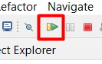

The "resume" command instructs the debugger to continue executing the program from the current paused state until the next breakpoint is encountered or until the program terminates. It effectively releases control back to the program, allowing it to proceed without interruption. This command is useful when developers have finished examining a particular section of code or when they want to continue the execution after making changes to variables or breakpoints.

After analyzing the failure and debugging the test, let’s switch back to the Java perspective and fix the test before running it again.

## Exception Handing in Selenium WebDriver

An exception, in programming, refers to an exceptional event that disrupts the normal flow of a program's instructions during execution. When an error occurs in a program, it generates an exception object containing information about the error. This process of creating an exception object and passing it to the runtime system is known as "throwing" an exception.

After an exception is thrown, the runtime system attempts to locate code that can handle it. This mechanism allows a program to gracefully respond to errors and continue its execution, even in the presence of exceptions. Handling exceptions involves providing instructions on how to deal with specific errors that may occur during program execution.

In summary, an exception is an occurrence that deviates from the expected behavior of a program, and handling exceptions enables programs to manage errors and maintain stability during execution.

**11 most common exceptions:**

[11 Most Common Exceptions In Selenium WebDriver (linkedin.com)](https://www.linkedin.com/pulse/11-most-common-exceptions-selenium-webdriver-logic-qa/)

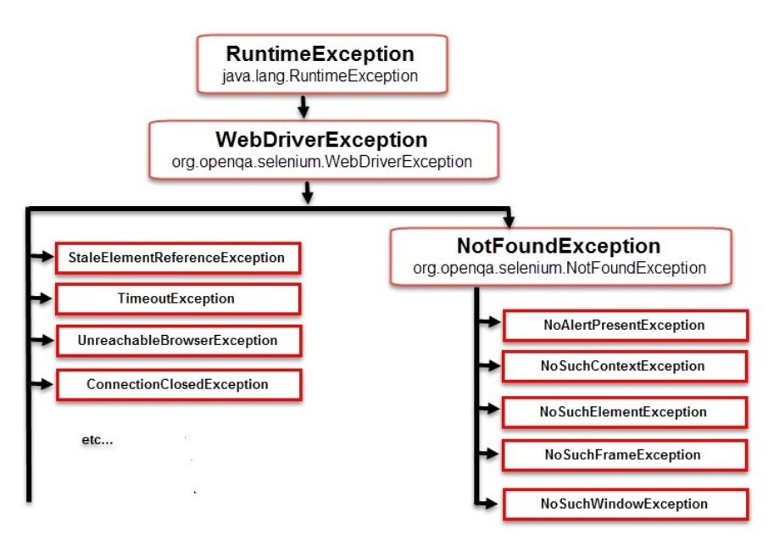

Let's create a new class called "ExceptionsTests" to explore and handle these exceptions. Here are the steps:

* Right-click on the package within the src/test/java directory.
* Choose "New" and then "Class."
* Name the class "ExceptionsTests" and click "Finish."
* Correct any typos in the class name to ensure it matches the filename.
  + You can do this by renaming the file to match the class name.

Now, let's copy and paste the setup and teardown methods into the ExceptionsTests class. These methods initialize the WebDriver instance and handle cleanup after each test.

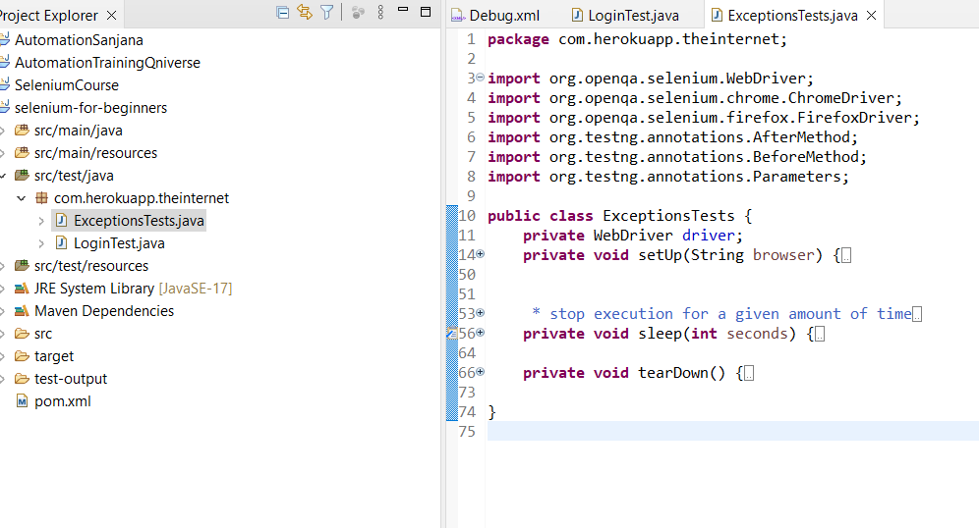

**Dummy website for exception handling exercise:**

[Test Exceptions | Practice Test Automation](https://practicetestautomation.com/practice-test-exceptions/)

## Dealing with NoSuchElementException in Selenium

Creating a method called homeworkTest in java class ExceptionTests:

@Test(groups= {"NoSuchElementException"})

**private** **void** homeworkTest() {

WebElement add_btn1 = driver.findElement(By.*xpath*("//div[@id='row1']//button[@id='add_btn']"));

add_btn1.click();

WebElement input2 = driver.findElement(By.*xpath*("//div[@id='row2']//input[@class='input-field']"));

Assert.*assertTrue*(input2.isDisplayed(), "Input field is not present");

}

Modifying test suite Debug.xml:

<!DOCTYPE suite SYSTEM "https://testng.org/testng-1.0.dtd">

<suite name="DebugSuite" verbose="1">

<test name="homeworkTest">

<parameter name="browser" value="chrome"></parameter>

<classes>

<class name="com.herokuapp.theinternet.ExceptionsTests">

<methods>

<include name="homeworkTest"></include>

</methods>

</class>

</classes>

</test>

</suite>

Now, test result after running the test suite with testNG:

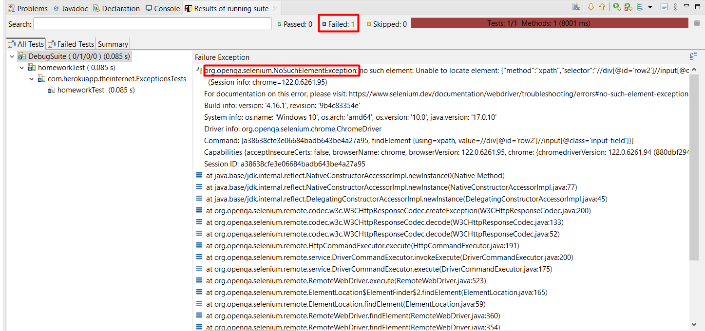

The NoSuchElementException is one of the most common exceptions encountered in Selenium testing. It typically occurs when the findElement or findElements methods of the WebDriver or WebElement classes are unable to locate an element with the provided locator.

Here's how you can handle and troubleshoot this exception:

* **Verify the Locator:** First, ensure that the locator used to find the element is correct. Inspect the page and verify that the locator accurately identifies the desired element.
* **Check for Delays:** Sometimes, elements may take some time to appear on the page, especially if the page is still loading or if there are dynamic elements. If you're running the test manually, you might see the element, but the automated test might execute faster than expected, resulting in the NoSuchElementException.
* **Add Wait:** To address timing issues, you can add a wait before attempting to find the element. This gives the page enough time to load the element before the test proceeds. While adding a wait is a quick solution, it's not the most efficient or robust method.

### Handling NoSuchElementException in Selenium with thread.sleep:

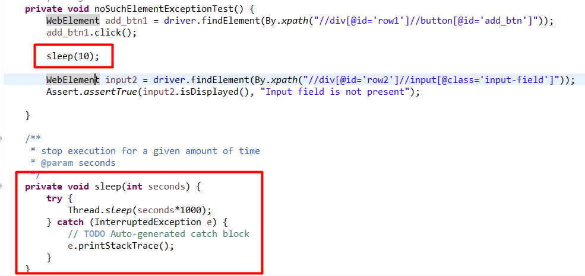

## Understanding WebDriver Waits in Selenium

When interacting with web pages and their elements, it's crucial to account for the fact that not all elements may be immediately available. Some elements may appear on the page with a slight delay, such as when clicking a button triggers the display of a new text field. This delay necessitates the use of waits in Selenium automation testing.

There are two main types of waits in Selenium:

1. **Implicit Wait:** This instructs the WebDriver to wait for a certain amount of time when attempting to find an element or elements if they are not immediately available. The default setting for an implicit wait is zero, but you can set it to a specific duration. Once set, the implicit wait remains in effect for the lifetime of the WebDriver object instance.
2. **Explicit Wait:** This is the code that you define to wait for a specific condition to occur before proceeding further in the code. Unlike implicit waits, explicit waits allow you to wait for a certain condition to be met before moving on with the test execution. A common example of an explicit wait is the WebDriverWait class in combination with an ExpectedCondition. Explicit waits are more flexible and precise compared to implicit waits.

It's important to avoid mixing implicit and explicit waits in your project, as doing so can lead to unpredictable wait times and potentially cause timeouts. For instance, setting an implicit wait of 10 seconds and an explicit wait of 15 seconds could result in a timeout occurring after 20 seconds, which may not be the desired behavior. Therefore, it's best practice to choose either implicit or explicit waits consistently throughout your project to ensure consistent and reliable test execution.

## Implementing Implicit Wait in Selenium Tests

To use an implicit wait in Selenium, follow these steps:

1. Identify the Need for a Wait: Determine where in your test code you need to wait for an element to become available before proceeding further.
2. Remove Thread Sleep: If you're currently using thread sleep to introduce a pause in your test execution, remove it to prepare for using implicit wait.
3. Set Up Implicit Wait: Set up an implicit wait to instruct the WebDriver to wait for a certain amount of time when trying to find an element if it's not immediately available.
4. Implement Implicit Wait: Implement the implicit wait by accessing the WebDriver's manage() method, followed by timeouts(), and then implicitlyWait(). Provide the duration for the wait using the Duration class.
5. Define Timeout Duration: Specify the duration for the implicit wait, usually in seconds, using the Duration.ofSeconds() method.
6. Apply the Wait: Save your changes and run your test. The WebDriver will now wait for the specified duration before attempting to find the element.

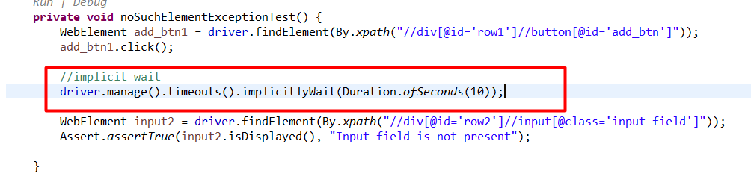

## Implementing Explicit Wait in Selenium Tests

Documentation: [Waiting Strategies | Selenium](https://www.selenium.dev/documentation/webdriver/waits/#explicit-waits)

To fix a test using Explicit Wait in Selenium, follow these steps:

1. Identify the Need for Wait: Determine where in your test code you need to wait for an element to become available before proceeding further.
2. Remove Implicit Wait: If you're currently using implicit wait, remove it, as you should not mix implicit and explicit waits.
3. Set Up Explicit Wait: Define a new instance of the WebDriverWait class with the desired timeout.
4. Choose a Condition: Choose a suitable condition from the ExpectedConditions class. In this example, we use visibilityOfElementLocated to wait until an element is both present in the DOM and visible on the page.
5. Apply the Wait: Use the WebDriverWait instance's until method along with the chosen condition to wait for the element to meet the specified condition.
6. Verify Test: Save your changes and run your test to verify that it now waits for the element to become visible before proceeding.

**private** **void** noSuchElementExceptionTest() {

WebElement add_btn1 = driver.findElement(By.*xpath*("//div[@id='row1']//button[@id='add_btn']"));

add_btn1.click();

// explicit wait

WebDriverWait wait = **new** WebDriverWait(driver, Duration.*ofSeconds*(10));

WebElement input2 = wait.until(ExpectedConditions.*visibilityOfElementLocated*(By.*xpath*("//div[@id='row2']//input[@class='input-field']")));

Assert.*assertTrue*(input2.isDisplayed(), "Input field is not present");

}

While implicit waits may appear convenient for basic scenarios, they often fall short in addressing all synchronization issues that may arise during test execution. Explicit waits offer a more robust solution by allowing testers to specify precise conditions for waiting, such as element visibility or clickability. However, it's crucial to avoid mixing implicit and explicit waits in test scripts, as this can lead to unpredictable behavior and longer wait times. Instead, testers are advised to disable or remove implicit waits entirely and rely solely on explicit waits. As test automation frameworks evolve, developers typically optimize the use of explicit waits by centralizing them in key areas, leading to more maintainable and efficient test suites. Ultimately, by understanding the differences between implicit and explicit waits and following best practices, testers can build more reliable and maintainable test automation solutions.

## Handling ElementNotInteractableException in Selenium

Let’s begin with automating test number two, which is expected to trigger an ElementNotInteractableException. The steps are straightforward: we need to open the same page, click the "Add" button, wait for the second row to load (similar to our first test), type text into the second input field, push the "Save" button using the locator By.name, and then verify that the text is saved.

**private** **void** elementNotInteractableExceptionTest() {

WebElement add_btn1 = driver.findElement(By.*xpath*("//div[@id='row1']//button[@id='add_btn']"));

add_btn1.click();

// explicit wait

WebDriverWait wait = **new** WebDriverWait(driver, Duration.*ofSeconds*(10));

WebElement input2 = wait.until(ExpectedConditions.*visibilityOfElementLocated*(By.*xpath*("//div[@id='row2']//input[@class='input-field']")));

Assert.*assertTrue*(input2.isDisplayed(), "Input field is not present");

input2.sendKeys("Cheese cake");

driver.manage().timeouts().implicitlyWait(Duration.*ofSeconds*(3));

WebElement save_btn = driver.findElement(By.*name*("Save"));

save_btn.click();

WebElement confirmationMessage = driver.findElement(By.*id*("confirmation"));

String expectedMessage = "Row 2 was added";

String actualMessage = confirmationMessage.getText();

Assert.*assertTrue*(actualMessage.contains(expectedMessage),

"Actual message doesn't contain expected message.”);

}

TestNG result:

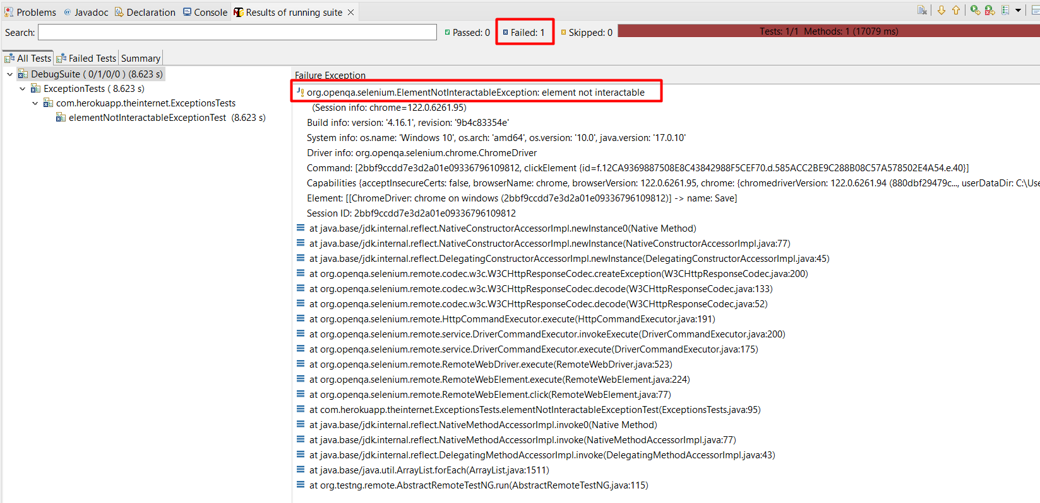

The webpage contains two element with name “Save” one is invisible and since, no interaction with invisible element can be found, the exception is encountered.

To rectify the issue in our test, we must locate a unique identifier that will precisely target the correct "Save" button. Let's revisit the page and inspect the element once more. We'll utilize XPath, just as we did with the input field, to create a distinct locator.

By employing XPath and crafting a precise locator, we can ensure that our test interacts with the correct "Save" button. This targeted approach will address the issue we encountered and enable our test to function reliably.

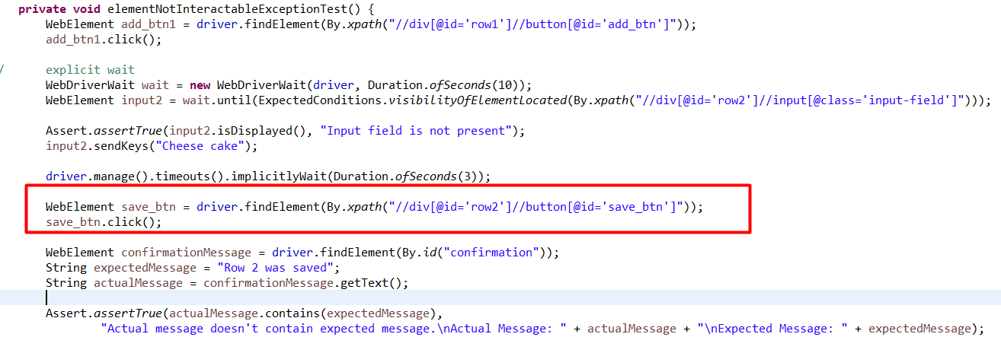

## Solving InvalidElementStateException in Selenium

Let’s create a method that will implement InvalidElementStateException:

@Test(groups= {"InvalidElementStateException"})

**private** **void** invalidElementStateExceptionTest() {

WebElement input = driver.findElement(By.*xpath*("//div[@id='row1']//input[@class='input-field']"));

String input_text = input.getText();

input.clear();

input.sendKeys("Burger");

String new_input = input.getAttribute("value");

System.***out***.println(input_text);

System.***out***.println(new_input);

}

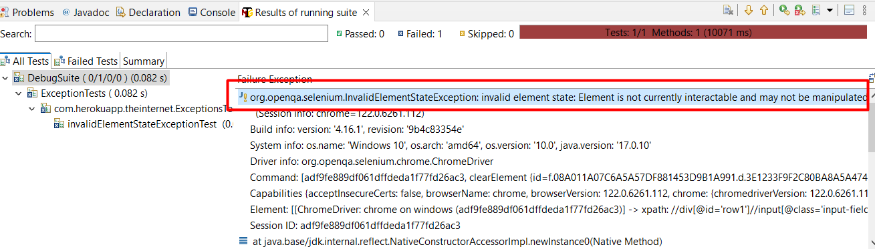

Here we are trying to modify the existing input value. However, we can notice that the input field is disabled which is why we aren’t allowed to add any value to it, and which is why we are encountering the specific exception.

If the input field is disabled, attempting to modify its value using Selenium WebDriver's sendKeys() method will result in an InvalidElementStateException because you cannot interact with a disabled input field.

To handle this situation in the test automation code, you would typically check if the input field is enabled before attempting to interact with it. If it's disabled, you might choose to skip the interaction or perform an alternative action based on your test requirements.

Here's how you can modify the code to check if the input field is enabled before trying to modify its value:

@Test(groups = {"InvalidElementStateException"})

**private** **void** invalidElementStateExceptionTest() {

WebElement input = driver.findElement(By.*xpath*("//div[@id='row1']//input[@class='input-field']"));

WebDriverWait wait = **new** WebDriverWait(driver, Duration.*ofSeconds*(10));

// Check if the input field is enabled

**if** (input.isEnabled()) {

String inputTextBefore = input.getAttribute("value");

// Clear the input field and enter new text

input.clear();

input.sendKeys("Burger");

// Retrieve the updated value

String inputTextAfter = input.getAttribute("value");

// Output the values for verification (optional)

System.***out***.println("Input text before: " + inputTextBefore);

System.***out***.println("Input text after: " + inputTextAfter);

// Assert that the new input text matches the expected value

Assert.*assertEquals*(inputTextAfter, "Burger", "Input text does not match the expected value");

} **else** {

System.***out***.println("Input field is disabled. Editing the field instead.");

WebElement edit_btn = driver.findElement(By.*xpath*("//div[@id='row1']//button[@id='edit_btn']"));

edit_btn.click();

WebElement input_field = driver.findElement(By.*xpath*("//div[@id='row1']//input[@class='input-field']"));

String inputTextBefore= input.getAttribute("value");

input_field.clear();

input_field.sendKeys("Burger");

String inputTextAfter= input.getAttribute("value");

// Output the values for verification (optional)

System.***out***.println("Input text before: " + inputTextBefore);

System.***out***.println("Input text after: " + inputTextAfter);

// Assert that the new input text matches the expected value

Assert.*assertEquals*(inputTextAfter, "Burger", "Input text does not match the expected value");

}

}

TestNG result:

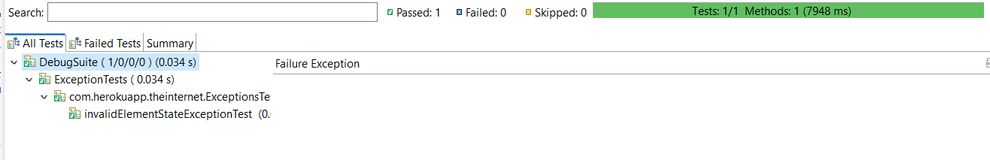

## Fixing StateElementReferenceException in Selenium

This issue persists if the element is deleted permanently or is no longer attached to the DOM. In this case the element is deleted. After click on add button, the element gets deleted and the isDisplayed() method cannot be called.

@Test(groups= {"StateElementReferenceException"})

**private** **void** stateElementReferenceExceptionTest() {

WebDriverWait wait = **new** WebDriverWait(driver, Duration.*ofSeconds*(10));

WebElement instruction = driver.findElement(By.*xpath*("//section[@id='food_list']//p[@id='instructions']"));

WebElement add_btn = driver.findElement(By.*xpath*("//div[@id='row1']//button[@id='add_btn']"));

add_btn.click();

Assert.*assertFalse*(instruction.isDisplayed(), "Instructions are still displayed");

}

TestNG result:

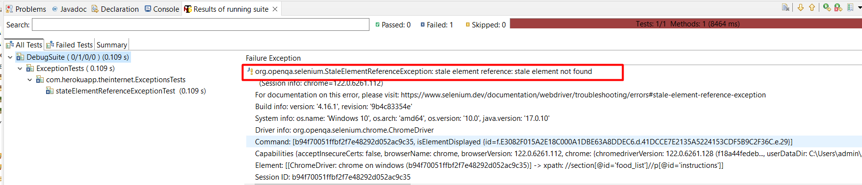

We can verify the absence of the element in a different way by adding explicit wait. In our case, In our case, we will wait for invisibility of our element, but not the actual web element. We would wait for invisibility of this locator.



So, let's add wait and change our assertion.

**private** **void** stateElementReferenceExceptionTest() {

WebDriverWait wait = **new** WebDriverWait(driver, Duration.*ofSeconds*(10));

WebElement add_btn = driver.findElement(By.*xpath*("//div[@id='row1']//button[@id='add_btn']"));

add_btn.click();

Assert.*assertTrue*(wait.until(ExpectedConditions.*invisibilityOfElementLocated*(By.*xpath*("//section[@id='food_list']//p[@id='instructions']"))), "Instructions are still displayed");

}

Now, if we try to test for invisibility of the instruction without, clicking on add button first, we get an error of timeout exception.

## Overcoming TimeoutException in Selenium Tests

A TimeoutException is a type of exception that occurs in software development and testing when a certain operation or condition takes longer than the specified timeout period to complete or be met. This exception is commonly encountered in scenarios where a program or test script is waiting for a specific condition or event to occur within a defined time frame but fails to do so within that time limit.

Here are some key points about TimeoutException:

1. **Cause:** TimeoutException is typically caused by delays in the execution of code or when an expected condition does not occur within the expected timeframe.
2. **Timeout Period:** It is important to set a timeout period for operations that involve waiting for certain conditions, such as waiting for a web element to load or waiting for a response from a server. If the operation exceeds the specified timeout period, a TimeoutException is thrown.
3. **Handling:** TimeoutException can be handled in code by implementing mechanisms such as retry logic, increasing the timeout duration, or implementing explicit waits. These strategies help mitigate the risk of TimeoutException and improve the robustness of the code.
4. **Common Scenarios:** TimeoutException is commonly encountered in automated testing scenarios, especially when using tools like Selenium for web testing. It can occur when waiting for elements to load, waiting for AJAX calls to complete, or waiting for page navigation to finish.
5. **Impact:** TimeoutException can impact the reliability and performance of software systems. It is important for developers and testers to understand the causes of TimeoutException and implement appropriate strategies to handle and mitigate its occurrence.

Implementation:

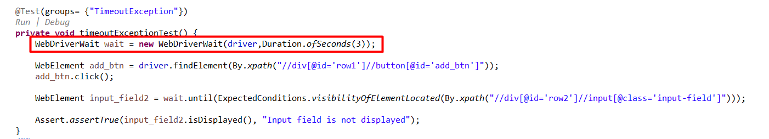

TestNG Result:

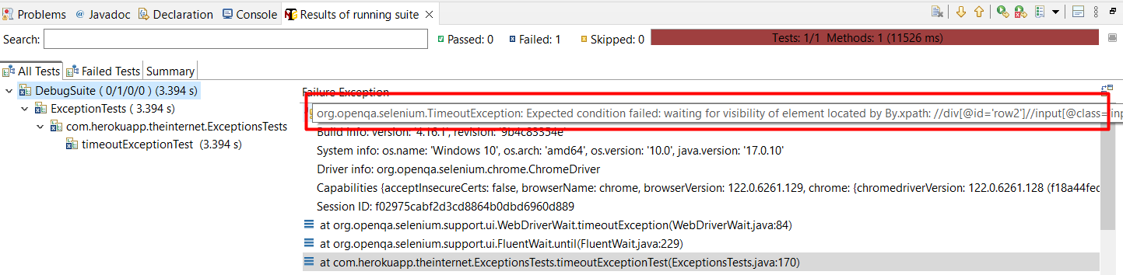

When the duration of seconds is increased this, issue no longer exists(duration is increased to 6 seconds):

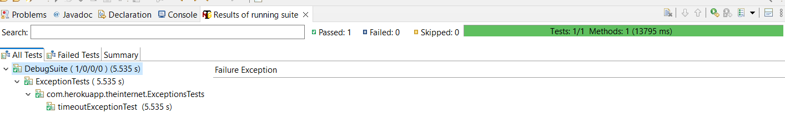

# **Introduction to Advanced Selenium WebDriver with Java and TestNG**

* BrowserDriver factory
* Page Object Model
* Data Driven Tests (DDT)
* Running tests in parallel
* Test automation tips and tricks